**FINAL PROJECT REPORT**

**ON**

**ONLINE EXAMINATION SYSTEM**

***Submitted by***

**Swati Sinha-16AU/466**

**MASTER OF COMPUTER APPLICATIONS**

***in***

**CENTRE OF COMPUTER EDUCATION**



**INSTITUTE OF PROFESSIONAL STUDIES**

UNIVERSITY OF ALLAHABAD

ALLAHABAD

**MAY – 2020**

**­CERTIFICATE**

This is to certify that the final Project report entitled “ONLINE EXAMINATION SYSTEM” submitted by *Swati Sinha*. The project report is approved for submission towards partial fulfillment of the requirement of MASTER OF COMPUTER APPLICATIONS in CENTER OF COMPUTER EDUCATION from “INSTITUTE OF PROFESSIONAL STUDIES, UNIVERSITY OF ALLAHABAD, PRAYAGRAJ (U.P.)”

**Prof. R.R.Tewari**

## (Course Coordinator)

**Centre of Computer Education**

#### CERTIFICATE

This is to certify that the final Project report entitled “ONLINE EXAMINATION SYSTEM*”* submitted by *Swati Sinha*. The project report is approved for submission towards partial fulfillment of the requirement of MASTER OF COMPUTER APPLICATIONS in CENTER OF COMPUTER EDUCATION from “INSTITUTE OF PROFESSIONAL STUDIES, UNIVERSITY OF ALLAHABAD, PRAYAGRAJ (U.P.)”

(Internal Examiner) (External Examiner)

Date: 30/05/20 Date:30/05/2020

#### DECLARATION

We hereby declare that the project entitled **“**ONLINE EXAMINATION SYSTEM**”** which is being submitted in partial fulfillment of the requirement for award of the Degree of MASTER OF COMPUTER APPLICATIONS in CENTER OF COMPUTER EDUCATION to “INSTITUTE OF PROFESSIONAL STUDIES, UNIVERSITY OF ALLAHABAD, PRAYAGRAJ (U.P.)” is an authentic record of our own work done under*,* CENTER OF COMPUTER EDUCATION, INSTITUTE OF PROFESSIONAL STUDIES, UNIVERSITY OF ALLAHABAD, PRAYAGRAJ(U.P.).

The matter reported in this Project has not been submitted earlier for the award of any other degree.

**Dated: 30/05/2020** *Swati Sinha*

*Place: PRAYAGRAJ*

**ACKNOWLEDGEMENT**

We take this opportunity to express deep sense of gratitude to “Prof. R.R. Tewari”, Course Coordinator of “Center of Computer Education” for his encouragement and kind approval. Also we thank him in providing the computer lab facility. We would like to express our sincere regards to him for advice and counseling from time to time.

We owe sincere thanks to Mrs. Sunita Tripathi(project incharge) and all the lecturers in “Center of Computer Education*”* for their advice and counseling time to time.

**Dated: 30/05/2020** *Swati Sinha*

Place: PRAYAGRAJ

**TABLE OF CONTENTS**

**CONTENTS PAGE NO.**

INTRODUCTION 7-8

FUNCTIONAL AND NON FUNCTIONAL REQUIREMENTS 9-12

OBJECTIVE AND SCOPE 13-13

MODULES 14-16

##### ARCHITECTURE(3 TIERED MODEL) 16-16

PROPOSED SYSTEM 17-17

DEFINATION OF PROBLEM 18-19

THEORETICAL BACKGROUND 20-20

SYSTEM DESIGN 21-27

DATABASE 28-29

IMPLEMENTATION 30-91

SCREEN SHOTS 92-104

CONCLUSION 105-105

FUTURE ENHANCEMENTS 106-106

REFRENCES 107-107

**INTRODUCTION**

Now- a -days “Online Examination System” is becoming popular as well as essential for every kinds of exams. It saves a lot of time, money and other expenses for any examine. In past days, there was a paper-pencil based test known as offline exam. It is generally offered in a single day for all candidates. This is a typical task for examination authorities and candidates to arrange everything.

**The drawbacks of normal Online Examination System are:**

* Online examination will reduce to huge work done by teachers, administration, and also students
* Responses by the candidates are going to be checked automatically and instantly.
* Reduce paper work.
* Results will show immediately that reduces student anxiety.
* Can be used anywhere anytime because it is web based application.
* Online examination can be conduct any time.

**Advantages of Online Examination System are:**

* Provides complete online web based solution, including student registration, giving tests, storing of results.
* Complete web based administration, administrator can manage can manage examination and question bank from web interface.
* No geograpical boundary.
* Student can give examination from anywhere of the world by 24x7.
* 100% accuracy in result calculation.
* Randomization of Question set.

**Limitations of the Online Examination System:**

* Time consuming for creating question paper.
* Time to check right and wrong answers.
* Calculations of marks.
* Human error.
* Limitation of no of student can give examination at a time.
* Require teacher to monitor exam center.
* Student needs to come at exam center for giving test.

**Scope of the Study -**

The modern computerized system is developed with the aim to overcome the drawbacks of existing manual system. We have to study manual examination system of ABC collage and identify possible automation. The proposed system has got many advantages. The new system is more personalized. It is made quick and easy referential manner. Securities for all important data are maintained confidentially. As it is easily understandable and user friendly, quick entries can be make in this system.

**FUNCTIONAL AND NON FUNCTIONAL REQUIREMENT**

**Functional Requirements**

Functional requirements are nothing but the services provided by the system to its end user.

There are three sub modules in this phase.

* Candidate module
* Administrator module

The functionality of each module is as follows.

**Candidate module:** The candidate will logon to the software and take examination. He can check his previous exam result and his details.

**Adminstrator module:** The database is prepared and loaded into the software. Selection can be done by the Administrator. The administrator collects all the result after successful completion of the examination.

**Interface requirements**

This section describes how the software interfaces with other products or users for input or output.

**User interface**

Application will be accessed through a browser interface. The interface would be viewed best using 1024 x768 and 800 x 600 pixels resolution setting. No user would be able to access any part of the application without logging on to the system.

**Non-functional Requirements**

**User Interfaces**

Application will be accessed through a browser interface. The interface would be viewed best using 1024 x768 and 800 x 600 pixels resolution setting. No user would be able to access any part of the application without logging on to the system.

* Registration Screen:

Various fields available on this screen will be:

* Firstname
* Lastname
* Username
* Password
* Email
* Contact
* Login Screen:

Fields available on this screen are:

* Username
* Password
* Admin login

Various Fields are:

* Username
* Password
* Entering Exam:

Various Fields are:

* Exam name
* Entering Questions

Various Fields are:

* Questions
* Options (4)
* Correct Answer
* Exam Details Screen:

Various Fields are:

* No. Of Questions
* Time Limit
* Result Displaying Screen:

Various Fields are:

* No of Questions
* No. Of Correct Questions
* No. Of Incorrect Questions
* Exam Time

**Hardware Interfaces**

Screen resolution of at least 800X600 is required for proper and complete viewing of screens. Higher resolution will be accepted.

* Intel 3.0 ghz or higher processor.
* 2 GB RAM
* 10 GB HDD space

**Software Interfaces**

Any windows based operating system.

* MySql Server Database
* HTML and CSS
* Php and javascript
* AJAX
* NetBeans / FrontPage / NotePad

**Other nonfunctional requirements**

**Performance Requirements**

Some performance requirement identified is listed below:

* The software shall support use of multiple users at a time. There are no other specific performance requirements that will affect development
* The database shall be able to accommodate a minimum of 10,000 records of students.

**Safety Requirements**

The database may get crashed at any certain time due to virus or operating system failure. Therefore, it is required to take the database backup.

**Security Requirements**

Some of the factors that are identified to protect the software from accidental or malicious access, use, modification, destruction or disclosure are described below.

* Keep specific log or history data sets
* Assign certain functions to different modules
* Restrict communication between same areas of the program
* Check data entries for critical variables
* Latest of the software will incorporate encryption techniques In the user/license authentication process
* Communication needs to be restricted when the application is validating the user or license. (i.e., using https)

OBJECTIVE AND SCOPE OF THE PROJECT

OBJECTIVE:

* Corporative between the data stored in the server of the institute and online exam system.To deal with online system in an easy way and efficient mannered.
* Specify privilege for each person to allow each person use this this system to create own exam.And have complete control on his exam.
* Allow each person to create more than one exam with different way to create variant question.

SCOPE:

* Online exam system is designed for Educational Institute (like school, collage, university and training center etc.)
* The system handles all the operation and generates reports as soon as the test is finish.
* The type of question is only multiple choice .

**MODULES**

**MODULES IN ONLINE EXAMINATION SYSTEM ARE:**

1. **Administrator end**
2. **User end**

**At administrator end-**

* **CREATE ACCOUNT**-Admin can create account and register the details of the admin.
* **ADMIN LOGIN**-Admin can login can control the system.
* **ADD EXAM-**Admin can add the exam details .He/she can edit and delete the exam.

#### ADD QUESTION-Admin can add,edit and delete.

* **EXAM RESULT-**Admin can retrieve data of all user result and delete them.
* **STUDENT DETAILS-**Admin can retrieve data of user and delete them.
* **ADMIN LOGOUT-**Admin can logout from the account.

**At user end-**

* **REGISTER-**User can register his/her details.
* **LOGIN**-User can login to their account .
* **EXAM FORM-**User can fill the exam to go to the examination by using his/ her batch .
* **SELECT EXAM-**User can select the exam and start it to the given period.
* **VIEW RESULT-**User can view the result after complete of exam.
* **OLD RESULT-**User can view the his/her all old result.
* **CONTACT US** -Customer can send mail if he/her has problem in examination.
* **LOGOUT-**User can logout from the account.

ARCHITECTURE OF ONLINE EXAMINATION SYSTEM

The Online Examination system Application is based on 3-tiered model

The 3-tiered architecture shown above has the following major components:  
• **Client**: There will be two clients for the application. One will be a web-based  
user-friendly client called student. The other will be for administration  
purposes.  
• **Application Server**: It checks for the SQL server connectivity for mapping to the database inorder to fulfill student and administrator’s request.

• **Database**: Database Servers will stores student and examination data.

PROPOSED SYSTEM

This application is used to conduct online examination. The students can sit at individual terminals and login to write the exam in the given duration. . The questions have to be given to the students.This application will perform correction, display the result immediately and also store it in database. This application provides the administrator with a facility to add new exams.This application provides the admin to add questions to the exam, modify questions in the exam in a particular exam. This application takes care of authentication of the administrator as well as the student.

DEFINITION OF PROBLEM

OnlineExamination is very helpful to users.The aim of this project is to provide quick,immediate and easy way to appear the exam .It can provide special advantage to the student/applicants.The online examination can marks allocated in each question to determine the total marks for te question.Atime limit can be set for the questions.Online examination systemallow jumping to specific question based on the previous answer.Theonline examination system limits the number of times a student can write a question.Login module helps user to login the site.For he/she must type the username and password correctly.The login provision in this page helps the already registered user to directly access te site and there is a link for registration to a user who is new in a site.Student module is mainly for the students.This system will provide the result after the exam according to correct and wrong answer.Administrator module is mainly for the administrator.This will contain the creation of question paper, preview of already created question , and report of all the student.

Advantages of Online Examination system

* Physical presence at a given location is absolutely not necessary.
* No time is spent on evalution.
* Rsults are available instantly.
* Can be easily accessed 24/7 over the open test period.
* Can be timed to allow Ytimes to answer X number of questions.
* Easy accessibility.
* Available at a reduced time.
* Accuracy in checking answer, calculating result.
* User friendly.
* Secure because of authentication.
* Online exams-convienced,security and flexibility.
* Exams can be assembled and previewed, edited and published instantly.

Disadvantages of Online Examination System

* Question are generally objective type so no chance to get marks for writing related question.
* Result can’t show pass/fail of the student it only show the no of question he/she attempted, correct anwer and wrong.
* It provide only multiple choicesbut single correct answer selection.
* Incase question and answer neeed to be in graphics, current system has no provision.
* Unregistered user can only access the home page ,contact and about page.
* Student only can him/her result by login.Top score are not displayed.
* If internet connection is slow it create problem.

THEORETICAL BACKGROUND

The background of system is a manual one in which users are maintaining books to store the information like Student Details,Instructor Details,Schedule Details and feedbacks about students who attempted exam as per schedule.. It is very difficult to maintain historical data.

DISADVANTAGES:

The following drawbacks ofbackground system emphasize the need for computerization:

1. A lot of copies of question papers have to be made

2. A lot of correction work hence delay in giving the results

3. A lot of tabulation work for each subject results

**SYSTEM DESIGN**

It should be done in 2 stages-

**Architectural Design**: it includes use case view.

**Use Case diagram**

Use cases are used during the analysis phase of a project to identify and partition system functionality. They separate the system into actors and use case. Use cases describe the behavior of the system when one of these actors sends one particular stimulus. This behavior is described textually. It describes the nature of the stimulus that triggers the use case; the inputs from and outputs to other actors, and the behaviors that convert the inputs to the outputs.

**MODULES OF USER AND ADIMISTRATION**

USE CASE DIAGRAM FOR Online Examination-

**ADMIN**

admin_window

cus_Master

**STUD**

**DATA FLOW DIAGRAM**

The DFD takes an input-process-output view of a system i.e. data objects flow into the software, are transformed by processing elements, and resultant data objects flow out of the software.

**LEVEL 0 DFD-**

STUD REGISTRATION

STUDENT

ADMIN

VERIFY USER

EXAM SCHEDULE

ADD QUESTION

ACCESS REGISTRATION VIEW USER

**LEVEL1 DFD-** GET INFO

LOGIN

STUDENT

GET A VISIT

GET A REPONSE GET INFO TO

ADMIN

ADMIN

#### LEVEL2DFD

**Taking Test**

**Taking Test**

Start Exam

End Exam

View Result

**E-R DIAGRAM**

The Entity-Relationship (ER) model was originally proposed by Peter in 1976 [Chen76] as a way to unify the network and relational database views. Simply stated the ER model is a conceptual data model that views the real world as entities and relationships. A basic component of the model is the Entity-Relationship diagram which is used to visually represents data objects. Since Chen wrote his paper the model has been extended and today it is commonly used for database design For the database designer, the utility of the ER model is:

* it maps well to the relational model. The constructs used in the ER model can easily be transformed into relational tables.
* it is simple and easy to understand with a minimum of training. Therefore, the model can be used by the database designer to communicate the design to the end user.
* In addition, the model can be used as a design plan by the database developer to implement a data model in a specific database management software

admin

student

1

1

n

appears

n

manages

exam

n

1

Exam form

n

select

has

subject

n

1

result

question

checks

**Database**

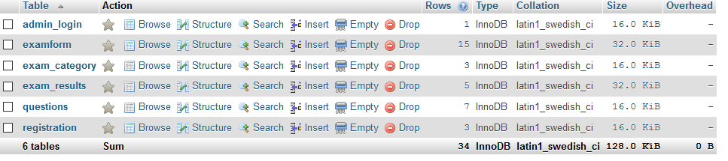

**Register table:**

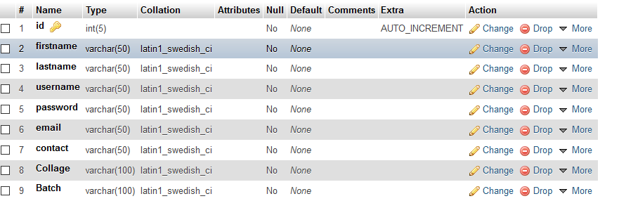

**Admin_login:**

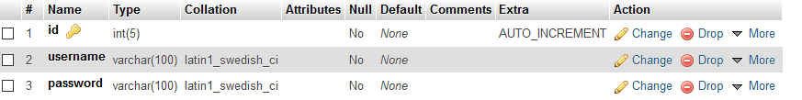

**Exam_category:**

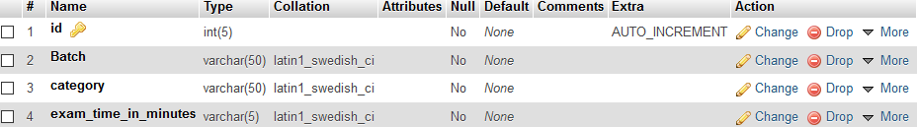

**Exam_result:**

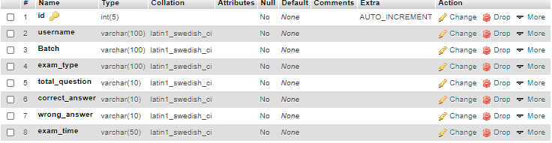

**Exam_form:**

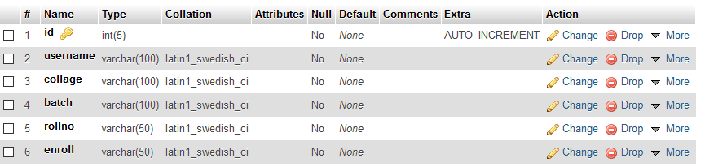

**Questions:**

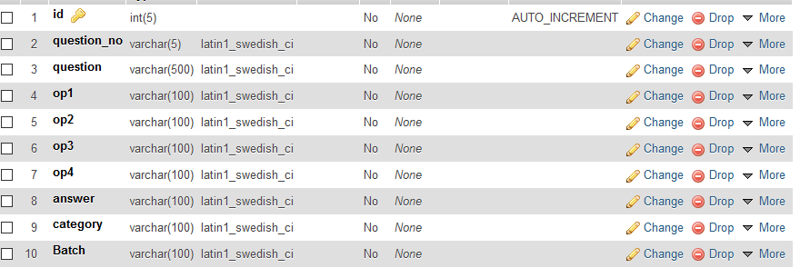

**IMPLEMENTATION**

**MAIN PAGE(The 1st Page home.aspx)-**

**Front end design code-**

<!DOCTYPE html>

<html lang="eng">

<head>

<meta charset="UTF-8">

<meta name="viewpoint" content="width=device-width,initial-scale=1.0">

<link rel="stylesheet" type="text/css" href="css/style.css">

<link rel="stylesheet" href="https://maxcdn.bootstrapcdn.com/bootstrap/4.0.0/css/bootstrap.min.css">

<link rel="stylesheet" href="https://cdnjs.cloudflare.com/ajax/libs/animate.css/4.0.0/animate.min.css" />

<title>ABC</title>

</head>

<body>

<header>

<nav class="navbar navbar-expand-lg navbar-dark bg-dark">

<div class="collapse navbar-collapse" id="navbarSupportedContent">

<ul class="navbar-nav ml-auto">

<ul class="nav nav-tabs" >

<li class="nav-item active">

<a class="nav-link" href="#">Home <span class="sr-only">(current)</span></a>

</li>

</ul>

<li class="nav-item">

<a class="nav-link" href="about.php">About</a>

</li>

<li class="nav-item">

<a class="nav-link" href="admin/index.php">Admin Login</a>

</li>

<li class="nav-item">

<a class="nav-link" href="contact.php">Contct us</a>

</li>

</ul>

</div>

</nav>

<main>

<section>

<h1>Welcome to <span class="change_content"></span></h1>

<a href="register.php" class="btnone">Register</a>

<a href="login.php" class="btntwo">Signup</a>

</section>

</main>

</header>

<script src="https://code.jquery.com/jquery-3.2.1.slim.min.js"></script>

<script src="https://cdnjs.cloudflare.com/ajax/libs/popper.js/1.12.9/umd/popper.min.js"></script>

<script src="https://maxcdn.bootstrapcdn.com/bootstrap/4.0.0/js/bootstrap.min.js"></script>

</body>

</html>

**SYLE.CSS-**

*{

margin: 0;

padding: 0;

font-family: Century Gothic;

box-sizing: border-box;

}

.navbar .navbar-nav li a{

color: red !important;

}

header{

width: 100%;height: 100vh;

background-image:linear-gradient(rgba(0,0,0,0.3),rgba(0,0,0,0.1)), url('../images/5.jpg');

background-repeat: no-repeat;

background-size: cover;

}

main{

width: 100%;

margin-top: 185px;

display: flex;

justify-content: center;

align-items: center;

text-align: center;

}

section h1{

margin: 30px 0 20px 0;

font-size: 55px;

color: white;

font-weight: 700;

text-shadow: 2px 1px 5px black;

text-transform: uppercase;

}

section a{

padding: 12px 30px;

border-radius: 4px;

outline: none;

text-transform: uppercase;

font-size: 13px;

font-weight: 500;

text-decoration: none;

letter-spacing: 1px;

transition: all .5s ease;

}

section .btnone{

/*background-color: #00b879;*/

background: #fff;

color:#000;

}

.btnone:hover{

background-color: #00b879;

color:white;

}

section .btntwo{

background-color: #00b879;

color:white;

}

.btntwo:hover{

background: #fff;

color:#000;

}

.change_content:after{

content: '';

animation: changetext 10s infinite linear;

color: #00b879;

}

@keyframes changetext{

0%{content:"Quiz Examination";}

100%{content: "Online Examination";}

}

**ADMIN PANEL-**

Index.php

<?php

session_start();

include "../connnection.php";

?>

<!doctype html>

<!--[if lt IE 7]> <html class="no-js lt-ie9 lt-ie8 lt-ie7" lang=""> <![endif]-->

<!--[if IE 7]> <html class="no-js lt-ie9 lt-ie8" lang=""> <![endif]-->

<!--[if IE 8]> <html class="no-js lt-ie9" lang=""> <![endif]-->

<!--[if gt IE 8]><!-->

<html class="no-js" lang="en">

<!--<![endif]-->

<head>

<meta charset="utf-8">

<meta http-equiv="X-UA-Compatible" content="IE=edge">

<title> Admin Login</title>

<meta name="viewport" content="width=device-width, initial-scale=1">

<link rel="stylesheet" href="vendors/bootstrap/dist/css/bootstrap.min.css">

<link rel="stylesheet" href="vendors/font-awesome/css/font-awesome.min.css">

<link rel="stylesheet" href="vendors/themify-icons/css/themify-icons.css">

<link rel="stylesheet" href="vendors/flag-icon-css/css/flag-icon.min.css">

<link rel="stylesheet" href="vendors/selectFX/css/cs-skin-elastic.css">

<link rel="stylesheet" href="assets/css/style.css">

<link href='https://fonts.googleapis.com/css?family=Open+Sans:400,600,700,800' rel='stylesheet' type='text/css'>

</head>

<body class="bg-dark">

<div class="sufee-login d-flex align-content-center flex-wrap">

<div class="container">

<div class="login-content">

<div class="login-logo" style="color: white">

Admin Login

</div>

<div class="login-form">

<form name="form1" action="" method="post">

<div class="form-group">

<label>Username</label>

<input type="text" name="username" class="form-control" placeholder="username" required>

</div>

<div class="form-group">

<label>Password</label>

<input type="password" name="password" class="form-control" placeholder="Password" required>

</div>

<button type="submit" name="submit1" class="btn btn-success btn-flat m-b-30 m-t-30">Sign in</button>

<div class="alert alert-danger" id="errormsg" style="margin-top: 10px;display: none">

<strong>Invalid!</strong>Username Or Password.

</div>

</form>

</div>

</div>

</div>

</div>

<script src="vendors/jquery/dist/jquery.min.js"></script>

<script src="vendors/popper.js/dist/umd/popper.min.js"></script>

<script src="vendors/bootstrap/dist/js/bootstrap.min.js"></script>

<script src="assets/js/main.js"></script>

</body>

</html>

<?php

if(isset($_POST["submit1"]))

{

$count=0;

$username=mysqli_real_escape_string($link,$_POST["username"]);

$password=mysqli_real_escape_string($link,$_POST["password"]);

$res=mysqli_query($link,"select * from admin_login where username='$username' && password='$password'");

$count=mysqli_num_rows($res);

if($count==0)

{

?>

<script type="text/javascript">

document.getElementById("errormsg").style.display="block";

</script>

<?php

}

else

{

$_SESSION["admin"]=$username;

?>

<script type="text/javascript">

window.location="exam_category.php";

</script>

<?php

}

}

?>

**CONNNECTION.PHP**

<?php

$link=mysqli_connect("localhost","root","");

mysqli_select_db($link,"online_quiz");

?>

**Exam_category.php**

<?php

session_start();

include ('header.php');

include('../connnection.php');

if (!isset($_SESSION["admin"])) {

# code...

?>

<script type="text/javascript">

window.location="../home.php";

</script>

<?php

}

?>

<div class="breadcrumbs">

<div class="col-sm-4">

<div class="page-header float-left">

<div class="page-title">

<h1>Add Exam</h1>

</div>

</div>

</div>

</div>

<div class="content mt-3">

<div class="animated fadeIn">

<div class="row">

<div class="col-lg-12">

<div class="card">

<form name="form1" action="" method="post">

<div class="class-body">

<div class="col-lg-6">

<div class="card">

<div class="card-header"><strong>Add Exam</strong>

</div>

<div class="card-body card-block">

<div class="form-group">

<label for="company" class=" form-control-label">New Batch</label>

<input type="text" placeholder="Add Batch" class=" form-control" name=" batch">

</div>

<div class="form-group">

<label for="company" class=" form-control-label">New Exam Category</label>

<input type="text" placeholder="Add Exam category" class=" form-control" name="examname">

</div>

<div class="form-group">

<label for="vat" class=" form-control-label">Exam Time In Minutes</label>

<input type="text" placeholder="Exam time in Minutes" class="form-control"name="examtime">

</div>

<div class="form-group">

<input type="submit" name="submit1" value="add exam" class="btn btn-success">

</div>

</div>

</div>

</div>

<div class="col-lg-6">

<div class="card">

<div class="card-header">

<strong class="card-title">Exam Categories</strong>

</div>

<div class="card-body">

<table class="table table-bordered">

<thead>

<tr>

<th scope="col">#</th>

<th scope="col">Batch</th>

<th scope="col">Exam Name</th>

<th scope="col">Exam Time</th>

<th scope="col">Edit</th>

<th scope="col">Delete</th>

</tr>

</thead>

<tbody>

<?php

$count=0;

$res=mysqli_query($link,"select * from exam_category");

while($row=mysqli_fetch_array($res))

{

$count=$count+1;

?>

<tr>

<th scope="row"><?php echo $count;?></th>

<td><?php echo $row["Batch"]; ?></td>

<td><?php echo $row["category"]; ?></td>

<td><?php echo $row["exam_time_in_minutes"]; ?></td>

<td><a href="edit_exam.php?id=<?php echo $row["id"]?>">Edit</a></td>

<td><a href="delete.php?id=<?php echo $row["id"];?>">Delete</a></td>

</tr>

<?php

}

?>

</tbody>

</table>

</div>

</div>

</div>

</form>

</div>

</div><!--/.col-->

</div><!-- .content -->

<?php

if(isset($_POST["submit1"]))

{

mysqli_query($link,"insert into exam_category values(NULL,'$_POST[batch]','$_POST[examname]','$_POST[examtime]')") or die(mysqli_error($link));

?>

<script type="text/javascript">

alert("exam added successfully");

window.location.href=window.location.href;

</script>

<?php

}

?>

<?php

include ('footer.php');

?>

**Add_edit exam_category.php**

<?php

session_start();

include ('header.php');

include ('../connnection.php');

if (!isset($_SESSION["admin"])) {

# code...

?>

<script type="text/javascript">

window.location="../home.php";

</script>

<?php

}

?>

<div class="breadcrumbs">

<div class="col-sm-12">

<div class="page-header float-left">

<div class="page-title">

<h1>Select Exam Categories For Add & Edit Questions</h1>

</div>

</div>

</div>

</div>

<div class="content mt-3">

<div class="animated fadeIn">

<div class="row">

<div class="col-lg-12">

<div class="card">

<div class="class-body">

<table class="table table-bordered">

<thead>

<tr>

<th scope="col">#</th>

<th scope="col">Batch</th>

<th scope="col">Exam Name</th>

<th scope="col">Exam Time</th>

<th scope="col">Select</th>

</tr>

</thead>

<tbody>

<?php

$count=0;

$res=mysqli_query($link,"select * from exam_category");

while($row=mysqli_fetch_array($res))

{

$count=$count+1;

?>

<tr>

<th scope="row"><?php echo $count;?></th>

<td><?php echo $row["Batch"]; ?></td>

<td><?php echo $row["category"]; ?></td>

<td><?php echo $row["exam_time_in_minutes"]; ?></td>

<td><a href="add_edit_question.php?id=<?php echo $row["id"]?>">Select</a></td>

</tr>

<?php

}

?>

</tbody>

</table>

</div>

</div>

</div><!--/.col-->

</div>

</div><!-----.animated---->

</div><!-- .content -->

<?php

include ('footer.php');

?>

**Add question.php**

<?php

session_start();

include ('header.php');

include ('../connnection.php');

if(!isset($_SESSION["admin"]))

{

# code...

?>

<script type="text/javascript">

window.location="../home.php";

</script>

<?php

}

$id=$_GET["id"];

$exam_category='';

$res=mysqli_query($link,"select * from exam_category where id=$id");

while($row=mysqli_fetch_array($res))

{

$batch=$row["Batch"];

$exam_category=$row["category"];

}

?>

<div class="breadcrumbs">

<div class="col-sm-6">

<div class="page-header float-left">

<div class="page-title">

<h1>Add Question inside <?php echo "<font color='red'>" .$exam_category."</font>";?> <?php echo "<font color='red'>" .$batch."</font>";?></h1>

</div>

</div>

</div>

</div>

<div class="content mt-3">

<div class="animated fadeIn">

<div class="row">

<div class="col-lg-12">

<div class="card">

<div class="class-body">

<div class="col-lg-6">

<form name="form1" action="" method="post" enctype="multipart/form-data">

<div class="card">

<div class="card-header"><strong>Add New Question With Text</strong>

</div>

<div class="card-body card-block">

<div class="form-group">

<label for="company" class=" form-control-label">Add Question</label>

<input type="text" placeholder="Add Question" class=" form-control" name="question" >

</div>

<div class="form-group"><label for="company" class=" form-control-label">Add Option1</label>

<input type="text" placeholder="Add op1" class=" form-control" name="op1" >

</div>

<div class="form-group">

<label for="company" class=" form-control-label">Add Option2</label>

<input type="text" placeholder="Add op2" class=" form-control" name="op2" >

</div>

<div class="form-group">

<label for="company" class=" form-control-label">Add Option3</label>

<input type="text" placeholder="Add op3" class=" form-control" name="op3" >

</div>

<div class="form-group">

<label for="company" class=" form-control-label">Add Option4</label>

<input type="text" placeholder="Add op4" class=" form-control" name="op4" >

</div>

<div class="form-group">

<label for="company" class=" form-control-label">Add Answer</label>

<input type="text" placeholder="Add Answer" class=" form-control" name="ans" >

</div>

<div class="form-group">

<input type="submit" name="submit1" value="Add Question" class="btn btn-success">

</div>

</div>

</div>

</div>

<div class="col-lg-6">

<form name="form1" action="" method="post">

<div class="card">

<div class="card-header"><strong>Add New Question With Images</strong>

</div>

<div class="card-body card-block">

<div class="form-group">

<label for="company" class=" form-control-label">Add Question</label>

<input type="text" placeholder="Add Question" class=" form-control" name="fquestion" >

</div>

<div class="form-group"><label for="company" class=" form-control-label">Add Option1</label>

<input type="file" class=" form-control" name="fop1" style="padding-bottom: 45px" >

</div>

<div class="form-group">

<label for="company" class=" form-control-label">Add Option2</label>

<input type="file" class=" form-control" name="fop2" style="padding-bottom: 45px" >

</div>

<div class="form-group">

<label for="company" class=" form-control-label">Add Option3</label>

<input type="file" class=" form-control" name="fop3" style="padding-bottom: 45px" >

</div>

<div class="form-group">

<label for="company" class=" form-control-label">Add Option4</label>

<input type="file" class=" form-control" name="fop4" style="padding-bottom: 45px">

</div>

<div class="form-group">

<label for="company" class=" form-control-label">Add Answer</label>

<input type="file" class=" form-control" name="fans" style="padding-bottom: 45px">

</div>

<div class="form-group">

<input type="submit" name="submit2" value="Add Question" class="btn btn-success">

</div>

</div>

</div>

</div>

</div>

</form>

</div>

</div>

</div><!--/.col-->

<div class="row">

<div class="col-lg-12">

<div class="card">

<div class="class-body">

<table class="table table-bordered">

<tr>

<th>no</th>

<th>Question</th>

<th>Option1</th>

<th>Option2</th>

<th>Option3</th>

<th>Option4</th>

<th>Edit</th>

<th>Delete</th>

</tr>

<?php

$count=0;

$res=mysqli_query($link,"select * from questions where Batch='$batch' and category ='$exam_category' order by question_no asc");

while ($row=mysqli_fetch_array($res))

{

$count=$count+1;

echo "<tr>";

echo "<td>"; echo $count; echo "</td>";

echo "<td>"; echo $row["question_no"]; echo "</td>";

echo "<td>"; echo $row["question"]; echo "</td>";

echo "<td>";

if(strpos($row["op1"],'opt_images/')!==false)

{

?>

<img src="<?php echo $row["op1"]; ?>" height="50" width="50">

<?php

}

else

{

echo $row["op1"];

}

echo "</td>";

echo "<td>";

if(strpos($row["op2"],'opt_images/')!==false)

{

?>

<img src="<?php echo $row["op2"]; ?>" height="50" width="50">

<?php

}

else

{

echo $row["op2"];

}

echo "</td>";

echo "<td>";

if(strpos($row["op3"],'opt_images/')!==false)

{

?>

<img src="<?php echo $row["op3"]; ?>" height="50" width="50">

<?php

}

else

{

echo $row["op3"];

}

echo "</td>";

echo "<td>";

if(strpos($row["op4"],'opt_images/')!==false)

{

?>

<img src="<?php echo $row["op4"]; ?>" height="50" width="50">

<?php

}

else

{

echo $row["op4"];

}

echo "</td>";

echo "<td>";

if(strpos($row["op4"],'opt_images/')!==false)

{

?>

<a href="edit_option_images.php?id=<?php echo $row["id"]; ?>&id1=<?php echo $id; ?>">Edit</a>

<?php

}

else

{

?>

<a href="edit_option.php?id=<?php echo $row["id"]; ?>&id1=<?php echo $id; ?>">Edit</a>

<?php

}

echo "</td>";

echo "<td>";

?>

<a href="Delete_option.php?id=<?php echo $row["id"]; ?>&id1=<?php echo $id; ?>">Delete</a>

<?php

echo "</td>";

echo "</tr>";

}

?>

</table>

</div>

</div>

</div>

</div>

</div>

</div><!-----.animated---->

</div><!-- .content -->

<?php

if(isset($_POST["submit1"]))

{

$loop=0;

$count=0;

$res=mysqli_query($link,"select * from questions where Batch='$batch' and category='$exam_category' order by id asc") or die(mysqli_error($link));

$count=mysqli_num_rows($res);

if($count==0)

{

}

else

{

while($row=mysqli_fetch_array($res))

{

$loop=$loop+1;

mysqli_query($link,"update questions set question_no='$loop' where id=$row[id]");

}

}

$loop=$loop+1;

mysqli_query($link,"insert into questions values(NULL,'$loop','$_POST[question]','$_POST[op1]','$_POST[op2]','$_POST[op3]','$_POST[op4]','$_POST[ans]','$exam_category','$batch')") or die (mysqli_error($link));

?>

<script type="text/javascript">

alert ("question added successfully");

window.location.href=window.location.href;

</script>

<?php

}

?>

<?php

if(isset($_POST["submit2"]))

{

$loop=0;

$count=0;

$res=mysqli_query($link,"select * from questions where Batch='$batch'and category='$exam_category' order by id asc") or die(mysqli_error($link));

$count=mysqli_num_rows($res);

if($count==0)

{

}

else

{

while($row=mysqli_fetch_array($res))

{

$loop=$loop+1;

mysqli_query($link,"update questions set question_no='$loop' where id=$row[id]");

}

}

$loop=$loop+1;

$tm=md5(time());

$fnm1=$_FILES["fop1"]["name"];

$dst1="./opt_images/".$tm.$fnm1;

$dst_db1="opt_images/".$tm.$fnm1;

move_uploaded_file($_FILES["fop1"]["tmp_name"],$dst1);

$fnm2=$_FILES["fop2"]["name"];

$dst2="./opt_images/".$tm.$fnm2;

$dst_db2="opt_images/".$tm.$fnm2;

move_uploaded_file($_FILES["fop2"]["tmp_name"],$dst2);

$fnm3=$_FILES["fop3"]["name"];

$dst3="./opt_images/".$tm.$fnm3;

$dst_db3="opt_images/".$tm.$fnm3;

move_uploaded_file($_FILES["fop3"]["tmp_name"],$dst3);

$fnm4=$_FILES["fop4"]["name"];

$dst4="./opt_images/".$tm.$fnm4;

$dst_db4="opt_images/".$tm.$fnm4;

move_uploaded_file($_FILES["fop4"]["tmp_name"],$dst4);

$fnm5=$_FILES["fans"]["name"];

$dst5="./opt_images/".$tm.$fnm5;

$dst_db5="opt_images/".$tm.$fnm5;

move_uploaded_file($_FILES["fans"]["tmp_name"],$dst5);

mysqli_query($link,"insert into questions values(NULL,'$loop','$_POST[fquestion]','$dst_db1','$dst_db2','$dst_db3','$dst_db4','$dst_db5','$exam_category','$batch')") or die (mysqli_error($link));

?>

<script type="text/javascript">

alert ("question added successfully");

window.location.href=window.location.href;

</script>

<?php

}

?>

<?php

include ('footer.php');

?>

**Studentdetails.php**

<?php

session_start();

include ('header.php');

include ('../connnection.php');

if(!isset($_SESSION["admin"])) {

# code...

?>

<script type="text/javascript">

window.location="../home.php";

</script>

<?php

}

?>

<div class="breadcrumbs">

<div class="col-sm-4">

<div class="page-header float-left">

<div class="page-title">

<h1>All Student Details</h1>

</div>

</div>

</div>

</div>

<div class="content mt-3">

<div class="animated fadeIn">

<div class="row">

<div class="col-lg-12">

<div class="card">

<div class="card-body">

<center>

<h1 style="color: #e53935" >Old Exam Results</h1>

</center>

<?php

$res=mysqli_query($link,"select * from registration order by id desc");

$count=mysqli_num_rows($res);

if($count==0)

{

?>

<center><h1 style="color: #fdd835">No Results Found</h1></center>

<?php

}

else

{

?>

<table class='table table-bordered'>

<tr style='background-color:#1de9b6;color:white'>

<td>Firstname</td>

<td>Lastname</td>

<td>Username</td>

<td>Password</td>

<td>Email</td>

<td>Contact</td>

<td>Collage</td>

<td>Batch</td>

<td>Action</td>

</tr>

<?php

$i=0;

while($row = mysqli_fetch_array($res)) {

$i++;

?>

<tr style='background-color:#c51162;color:white'>

<td><?php echo $row["firstname"]; ?></td>

<td><?php echo $row["lastname"]; ?></td>

<td><?php echo $row["username"]; ?></td>

<td><?php echo $row["password"]; ?></td>

<td><?php echo $row["email"]; ?></td>

<td><?php echo $row["contact"]; ?></td>

<td><?php echo $row["Collage"]; ?></td>

<td><?php echo $row["Batch"]; ?></td>

<td><a href="delete-process1.php?id=<?php echo $row["id"]; ?>">Delete</a></td>

</tr>

<?php

}

}

?>

</table>

</div>

</div>

</div><!--/.col-->

</div>

</div><!-----.animated---->

</div><!-- .content -->

<?php

include ('footer.php');

?>

**Result detail.php**

<?php

session_start();

include ('header.php');

include ('../connnection.php');

if(!isset($_SESSION["admin"])) {

# code...

?>

<script type="text/javascript">

window.location="../home.php";

</script>

<?php

}

?>

<div class="breadcrumbs">

<div class="col-sm-4">

<div class="page-header float-left">

<div class="page-title">

<h1>All Exam Results</h1>

</div>

</div>

</div>

</div>

<div class="content mt-3">

<div class="animated fadeIn">

<div class="row">

<div class="col-lg-12">

<div class="card">

<div class="card-body">

<center>

<h1 style="color: #e53935" >Old Exam Results</h1>

</center>

<?php

$res=mysqli_query($link,"select * from exam_results order by id desc");

$count=mysqli_num_rows($res);

if($count==0)

{

?>

<center><h1 style="color: #fdd835">No Results Found</h1></center>

<?php

}

else

{

?>

<table class='table table-bordered'>

<tr style='background-color:#1de9b6;color:white'>

<td>username</td>

<td>Batch</td>

<td>exam_type</td>

<td>total_question</td>

<td>correct_answer</td>

<td>wrong_answer</td>

<td>exam_time</td>

<td>Action</td>

</tr>

<?php

$i=0;

while($row = mysqli_fetch_array($res)) {

$i++;

?>

<tr style='background-color:#c51162;color:white'>

<td><?php echo $row["username"]; ?></td>

<td><?php echo $row["Batch"]; ?></td>

<td><?php echo $row["exam_type"]; ?></td>

<td><?php echo $row["total_question"]; ?></td>

<td><?php echo $row["correct_answer"]; ?></td>

<td><?php echo $row["wrong_answer"]; ?></td>

<td><?php echo $row["exam_time"]; ?></td>

<td><a href="delete-process.php?id=<?php echo $row["id"]; ?>">Delete</a></td>

</tr>

<?php

}

}

?>

</table>

</div>

</div>

</div><!--/.col-->

</div>

</div><!-----.animated---->

</div><!-- .content -->

<?php

include ('footer.php');

?>

**Logout.php**

<?php

session_start();

session_destroy();

?>

<script type="text/javascript">

window.location="../home.php";

</script>

**USERSIDE:**

1. **Register.php**

<?php

//register.php

include('connnection.php');

?>

<!DOCTYPE html>

<html lang="en">

<head>

<meta charset="utf-8">

<meta http-equiv="x-ua-compatible" content="ie=edge">

<title>Register</title>

<meta name="description" content="">

<meta name="viewport" content="width=device-width, initial-scale=1">

<link href="https://fonts.googleapis.com/css?family=Play:400,700" rel="stylesheet">

<link rel="stylesheet" href="https://maxcdn.bootstrapcdn.com/bootstrap/4.0.0/css/bootstrap.min.css">

<link rel="stylesheet" href="css1/bootstrap.min.css">

<link rel="stylesheet" href="css1/font-awesome.min.css">

<link rel="stylesheet" href="css1/owl.carousel.css">

<link rel="stylesheet" href="css1/owl.theme.css">

<link rel="stylesheet" href="css1/owl.transitions.css">

<link rel="stylesheet" href="css1/animate.css">

<link rel="stylesheet" href="css1/normalize.css">

<link rel="stylesheet" href="css1/main.css">

<link rel="stylesheet" href="css/style1.css">

<link rel="stylesheet" type="text/css" href="css/style4.css">

<link rel="stylesheet" href="css1/responsive.css">

<script src="js/vendor/modernizr-2.8.3.min.js"></script>

</head>

<body>

<nav class="navbar navbar-expand-lg navbar-dark bg-dark">

<div class="collapse navbar-collapse" id="navbarSupportedContent">

<ul class="navbar-nav ml-auto">

<li class="nav-item ">

<a class="nav-link" href="home.php">Home <span class="sr-only"></span></a>

</li>

<li class="nav-item">

<a class="nav-link" href="about.php">About</a>

</li>

<li class="nav-item">

<a class="nav-link" href="admin/index.php">Admin Login</a>

</li>

<li class="nav-item">

<a class="nav-link" href="contact.php">Contct us</a>

</li>

<ul class="nav nav-tabs" >

<li class="nav-item active">

<a class="nav-link" href="#">Register <span class="sr-only">(current)</span></a>

</li>

</ul>

</ul>

</div>

</nav>

<div class ="error-pagewrap">

<div class="error-page-int">

<div class="text-center custom-login">

<img src="images/1.jpeg" class="img-fluid" width="300" alt="Online Examination System " />

<h3>register</h3>

</div>

<div class="content-error">

<div class="hpanel">

<div class="panel-body">

<form action="" name="form1" method="post">

<div class="row">

<div class="form-group col-lg-12">

<label>Firstname</label>

<input type="text" name="firstname" class="form-control">

</div>

<div class="form-group col-lg-12">

<label>Lastname</label>

<input type="text" name="lastname" class="form-control">

</div>

<div class="form-group col-lg-12">

<label>Username</label>

<input type="text" name="username" class="form-control">

</div>

<div class="form-group col-lg-12">

<label>Password</label>

<input type="Password" name="password" class="form-control">

</div>

<div class="form-group col-lg-12">

<label>Email</label>

<input type="text" name="email" class="form-control">

</div>

<div class="form-group col-lg-12">

<label>Contact</label>

<input type="text" name="contact" class="form-control">

</div>

<div class="form-group col-lg-12">

<label>Collage</label>

<input type="text" name="contact" class="form-control">

</div>

<div class="form-group col-lg-12">

<label>Batch</label>

<input type="text" name="contact" class="form-control">

</div>

</div>

<div class="text-center">

<button type="submit" name="submit1" class="btn btn-success loginbtn">Register</button>

</div>

<div class="alert alert-success"id="success" style="margin-top: 10px; display:none">

<strong>Success!</strong> Account Registration Successfully.

</div>

<div class="alert alert-danger" id="failure" style="margin-top: 10px; display: none">

<strong>Already Exist!</strong> This Username is Already Exist.

</div>

</form>

</div>

</div>

</div>

</div>

</div>

</div>

<?php

if(isset($_POST["submit1"]))

{

$count=0;

$res=mysqli_query($link,"select * from registration where Username='$_POST[username]'") or die(mysqli_error($link));

$count=mysqli_num_rows($res);

if($count>0)

{

?>

<script type="text/javascript">

document.getElementById("success").style.display="none";

document.getElementById("failure").style.display="block";

</script>

<?php

}

else

{

mysqli_query($link,"insert into registration values(NULL,'$_POST[firstname]','$_POST[lastname]','$_POST[username]','$_POST[password]','$_POST[email]','$_POST[contact]')");

?>

<script type="text/javascript">

document.getElementById("success").style.display="block";

document.getElementById("failure").style.display="none";

</script>

<?php

}

}

?>

<div class="footer-copyright-area">

<div class="container-fluid">

<div class="row">

<div class="col-lg-12">

<div class="footer-copy-right">

<p>Copyright © 2020.</p>

</div>

</div>

</div>

</div>

</div>

</div>

<script src="js/vendor/jquery-1.12.4.min.js"></script>

<script src="js/bootstrap.min.js"></script>

<script src="js/wow.min.js"></script>

<script src="js/jquery-price-slider.js"></script>

<script src="js/jquery.meanmenu.js"></script>

<script src="js/owl.carousel.min.js"></script>

<script src="js/jquery.sticky.js"></script>

<script src="js/jquery.scrollUp.min.js"></script>

<script src="js/plugins.js"></script>

<script src="js/main.js"></script>

</body>

</html>

**Login.php**

<?php

//login.php

session_start();

include('connnection.php');

?>

<!doctype html>

<html class="no-js" lang="en">

<head>

<meta charset="utf-8">

<meta http-equiv="x-ua-compatible" content="ie=edge">

<title>Login</title>

<meta name="description" content="">

<meta name="viewport" content="width=device-width, initial-scale=1">

<link rel="stylesheet" href="https://maxcdn.bootstrapcdn.com/bootstrap/4.0.0/css/bootstrap.min.css">

<link href="https://fonts.googleapis.com/css?family=Play:400,700" rel="stylesheet">

<link rel="stylesheet" href="css1/bootstrap.min.css">

<link rel="stylesheet" href="css1/font-awesome.min.css">

<link rel="stylesheet" href="css1/owl.carousel.css">

<link rel="stylesheet" href="css1/owl.theme.css">

<link rel="stylesheet" href="css1/owl.transitions.css">

<link rel="stylesheet" href="css1/animate.css">

<link rel="stylesheet" href="css1/normalize.css">

<link rel="stylesheet" href="css1/main.css">

<link rel="stylesheet" href="css/style1.css">

<link rel="stylesheet" type="text/css" href="css/style4.css">

<link rel="stylesheet" href="css1/responsive.css">

<script src="js/vendor/modernizr-2.8.3.min.js"></script>

</head>

<body>

<nav class="navbar navbar-expand-lg navbar-dark bg-dark">

<div class="collapse navbar-collapse" id="navbarSupportedContent">

<ul class="navbar-nav ml-auto">

<li class="nav-item ">

<a class="nav-link" href="home.php">Home <span class="sr-only"></span></a>

</li>

<li class="nav-item">

<a class="nav-link" href="about.php">About</a>

</li>

<li class="nav-item">

<a class="nav-link" href="admin/index.php">Admin Login</a>

</li>

<li class="nav-item">

<a class="nav-link" href="contact.php">Contct us</a>

</li>

<ul class="nav nav-tabs" >

<li class="nav-item active">

<a class="nav-link" href="#">Login <span class="sr-only">(current)</span></a>

</li>

</ul>

</ul>

</div>

</nav>

<div class="error-pagewrap">

<div class="error-page-int">

<div class="text-center m-b-md custom-login">

<img src="images/1.jpeg" class="img-fluid" width="300" alt="Online Examination System " />

<h3>LOGIN FORM</h3>

</div>

<div class="content-error">

<div class="hpanel">

<div class="panel-body">

<form action="" name="form1" method="post">

<div class="form-group">

<label class="control-label" for="username">Username</label>

<input type="text" placeholder="example@gmail.com" title="Please enter you username" required="" name="username" id="username" class="form-control">

</div>

<div class="form-group">

<label class="control-label" for="password">Password</label>

<input type="password" title="Please enter your password" placeholder="******" required="" value="" name="password" id="password" class="form-control">

</div>

<button type="submit" name="login" class="btn btn-success btn-block loginbtn">Login</button>

<a class="btn btn-default btn-block" href="register.php">Register</a>

<div class="alert alert-danger" id="failure" style="margin-top: 10px; display: none">

<strong>Does Not Exist!</strong> Invalid Username or Password.

</div>

</form>

</div>

</div>

</div>

</div>

</div>

<?php

if(isset($_POST["login"]))

{

$count=0;

$res=mysqli_query($link,"select * from registration where username='$_POST[username]' &&

password='$_POST[password]'");

$count=mysqli_num_rows($res);

if($count==0)

{

?>

<script type="text/javascript">

document.getElementById("failure").style.display="block";

</script>

<?php

}

else

{

$_SESSION["username"]=$_POST["username"];

?>

<script type="text/javascript">

window.location="examform.php";

</script>

<?php

}

}

?>

<div class="footer-copyright-area">

<div class="container-fluid">

<div class="row">

<div class="col-lg-12">

<div class="footer-copy-right">

<p>Copyright © 2020.</p>

</div>

</div>

</div>

</div>

</div>

</div>

<script src="js/vendor/jquery-1.12.4.min.js"></script>

<script src="js/bootstrap.min.js"></script>

<script src="js/wow.min.js"></script>

<script src="js/jquery-price-slider.js"></script>

<script src="js/jquery.meanmenu.js"></script>

<script src="js/owl.carousel.min.js"></script>

<script src="js/jquery.sticky.js"></script>

<script src="js/jquery.scrollUp.min.js"></script>

</body>

</html>

**Examform.php**

<?php

session_start();

include "connnection.php";

include "header2.php";

if(!isset($_SESSION["username"]))

{

?>

<script type="text/javascript">

window.location="home.php";

</script>

<?php

}

if($_SERVER['REQUEST_METHOD']=='POST')

{

$_SESSION['batch']=$_POST['batch'];

if($_SESSION['batch']){

header('location:select_exam.php');

}

}

?>

<div class="row" style="margin: 0px; padding:0px; margin-bottom: 50px;">

<br>

<br>

<center>

<p style="font-weight: bold;font-size: 26px;color:black"> Please fill the form for the process of examination!</p>

</center>

<div class="col-lg-6 col-lg-push-3" style="min-height: 500px; background-color: white;">

<br>

<br>

<form action="examform.php" name="form1" method="POST">

<div class="form-group">

<label class="control-label" for="username">Collage</label>

<input type="text" placeholder="collage" title="Please enter your collage name" required="" name="collage" id="collage" class="form-control">

</div>

<div class="form-group">

<label class="control-label" for="password">Batch</label>

<input type="text" title="Please enter your batch" placeholder="Batch" required="" value="" name="batch" id="batch" class="form-control">

</div>

<div class="form-group">

<label class="control-label" for="password">Rollno</label>

<input type="text" title="Please enter your password" placeholder="4566" required="" value="" name="rollno" id="rollno" class="form-control">

</div>

<div class="form-group">

<label class="control-label" for="password">Enrollno</label>

<input type="text" title="Please enter your password" placeholder="67789" required="" value="" name="enrollno" id="enrollno" class="form-control">

</div>

<button type="submit" name="submit1" class="btn btn-success btn-block loginbtn">Submit</button>

<div class="alert alert-success"id="success" style="margin-top: 10px; display:none">

<strong>Success!</strong> Form Submitted.

</div>

<div class="alert alert-danger" id="failure" style="margin-top: 10px; display: none">

<strong>Already Exist!</strong>Please check your form .

</div>

</form>

</div>

</div>

<?php

if(isset($_POST["submit1"]))

{

mysqli_query($link,"insert into examform values(NULL,'$_SESSION[username]','$_POST[collage]','$_POST[batch]','$_POST[rollno]','$_POST[enrollno]')") or die(mysqli_error($link));

?>

<script type="text/javascript">

document.getElementById("success").style.display="block";

document.getElementById("failure").style.display="none";

</script>

<?php

}

?>

<?php

include "footer.php";

?>

**Selectexam.php**

<?php

session_start();

if(!isset($_SESSION["username"]))

{

?>

<script type="text/javascript">

window.location="home.php";

</script>

<?php

}

$batch=$_SESSION['batch'];

?>

<?php

include "connnection.php";

include "header.php";

?>

<div class="row" style="margin: 0px; padding:0px; margin-bottom: 50px;">

<div class="col-lg-6 col-lg-push-3" style="min-height: 500px; background-color: white;">

<?php

$res=mysqli_query($link,"select * from exam_category where Batch='$batch'") or die(mysqli_error($link));

while($row=mysqli_fetch_array($res))

{

?>

<input type="button" class="btn btn-success form-control" value="<?php echo $row["category"]; ?>" style="margin-top: 10px; background-color: blue; color: white" onclick="set_exam_type_session(this.value);">

<?php

}

?>

</div>

</div>

<?php

include "footer.php";

?>

<script type="text/javascript">

function set_exam_type_session(exam_category)

{

var xmlhttp=new XMLHttpRequest();

xmlhttp.onreadystatechange=function() {

if (xmlhttp.readyState == 4 && xmlhttp.status == 200) {

window.location = "dashboard.php";

}

};

xmlhttp.open("GET","forajax/set_exam_type_session.php?exam_category="+ exam_category,true);

xmlhttp.send(null);

}

</script>

**set_exam_type_session.php**

<?php

session_start();

include "../connnection.php";

$exam_category=$_GET["exam_category"];

$_SESSION["exam_category"]=$exam_category;

$res=mysqli_query($link,"select * from exam_category where category='$exam_category'");

while($row=mysqli_fetch_array($res))

{

$_SESSION["exam_time"]=$row["exam_time_in_minutes"];

}

date_default_timezone_set('Asia/Kolkata');

$date = date("Y-m-d H:i:s");

$_SESSION["end_time"]=date("Y-m-d H:i:s",strtotime($date ."+ $_SESSION[exam_time] minutes"));

$_SESSION["exam_start"]="yes";

?>

**Dashboard.php**

<?php

session_start();

include ('connnection.php');

include ('header.php');

if (!isset($_SESSION["username"])) {

# code...

?>

<script type="text/javascript">

window.location="home.php";

</script>

<?php

}

?>

<div class="row" style="margin: 0px; padding:0px; margin-bottom: 50px;">

<div class="col-lg-6 col-lg-push-3" style="min-height: 500px; background-color: white;">

<!----------start editing------>

<br>

<div class="row">

<br>

<div class="col-lg-2 col-lg-push-10">

<div id="current_que" style="float: left">0</div>

<div style="float: left">/</div>

<div id="total_que" style="float: left">0</div>

</div>

<div class="row" style="margin-top: 30px">

<div class="row">

<div class="col-lg-10 col-lg-push-1" style="min-height: 300px ;background-color: white" id="load_questions">

</div>

</div>

</div>

<div class="row" style="margin-top: 10px">

<div class="col-lg-6 col-lg-push-3" style="min-height: 50px">

<div class="col-lg-12 text-center">

<input type="button" class="btn btn-warning" value="previous"

onclick="load_previous();">&nbsp;

<input type="button" class="btn btn-success" value="next"

onclick="load_next();">&nbsp;

<input type="button" class="btn btn-info" value="submit"

onclick="load_submit();">

</div>

</div>

</div>

</div>

<!-----------end her editing---------->

</div>

</div>

<script type="text/javascript">

function load_total_que()

{

var xmlhttp=new XMLHttpRequest();

xmlhttp.onreadystatechange=function() {

if (xmlhttp.readyState == 4 && xmlhttp.status == 200) {

document.getElementById("total_que").innerHTML=xmlhttp.responseText;

}

};

xmlhttp.open("GET","forajax/load_total_que.php",true);

xmlhttp.send(null);

}

var questionno="1";

load_questions(questionno);

function load_questions(questionno)

{

document.getElementById("current_que").innerHTML=questionno;

var xmlhttp=new XMLHttpRequest();

xmlhttp.onreadystatechange=function() {

if (xmlhttp.readyState == 4 && xmlhttp.status == 200) {

if (xmlhttp.responseText=="over")

{

load_submit();

}

else

{

document.getElementById("load_questions").innerHTML=xmlhttp.responseText;

load_total_que();

}

}

};

xmlhttp.open("GET","forajax/load_questions.php?questionno="+ questionno,true);

xmlhttp.send(null);

}

function radioclick(radiovalue,questionno)

{

var xmlhttp=new XMLHttpRequest();

xmlhttp.onreadystatechange=function() {

if (xmlhttp.readyState == 4 && xmlhttp.status == 200) {

}

};

xmlhttp.open("GET","forajax/save_answer.php?questionno="+ questionno +"&value1="+ radiovalue,true);

xmlhttp.send(null);

}

function load_previous()

{

if(questionno=="1")

{

load_questions(questionno);

}

else

{

questionno=eval(questionno)-1;

load_questions(questionno);

}

}

function load_next()

{

questionno=eval(questionno)+1;

load_questions(questionno);

}

function load_submit()

{

window.location="result.php";

}

</script>

<?php

include "footer.php";

?>

**Result.php**

<?php

session_start();

include ('connnection.php');

date_default_timezone_set('Asia/Kolkata');

$date=date("Y-m-d H:i:s");

$_SESSION["end_time"]=date("Y-m-d H:i:s",strtotime($date ."+ $_SESSION[exam_time] minutes"));

include "header2.php";

?>

<div class="row" style="margin: 0px; padding:0px; margin-bottom: 50px;">

<div class="col-lg-6 col-lg-push-3" style="min-height: 500px; background-color: white;">

<br>

<center><h4 style="color: black">Result</h4></center>

<?php

$correct=0;

$wrong=0;

if(isset($_SESSION["answer"]))

{

for ($i=1; $i <=sizeof($_SESSION["answer"]); $i++) {

# code...

$answer="";

$res=mysqli_query($link,"select * from questions where category='$_SESSION[exam_category]' && question_no=$i");

while ($row=mysqli_fetch_array($res))

{

# code...

$answer=$row["answer"];

}

if (isset($_SESSION["answer"][$i]))

{

# code...

if ($answer==$_SESSION["answer"][$i])

{

# code...

$correct=$correct+1;

}

else

{

$wrong=$wrong+1;

}

}

else

{

$wrong=$wrong+1;

}

}

}

$count=0;

$res=mysqli_query($link,"select * from questions where category='$_SESSION[exam_category]'");

$count=mysqli_num_rows($res);

$wrong=$count-$correct;

?>

<table style="border:1px solid black;border-collapse:collapse;margin-left:auto;margin-right:auto; width:100%;background-color: #f1f1c1;position: absolute;left: 0%;">

<tr>

<th>No Of Questions</th>

<th>Corrrect Answer</th>

<th>Wrong Answer</th>

<th>Time</th>

</tr>

<td><?php echo $count; ?></td>

<td><?php echo $correct; ?></td>

<td><?php echo $wrong; ?></td>

<td><?php echo $date;?></td>

</table>

</div>

</div>

<?php

if(isset($_SESSION["exam_start"]))

{

$date=date("Y-m-d");

mysqli_query($link,"insert into exam_results(id,username,exam_type,total_question,correct_answer,wrong_answer,exam_time)values(NULL,'$_SESSION[username]','$_SESSION[exam_category]','$count','$correct','$wrong','$date')");

}

if (isset($_SESSION["exam_start"]))

{

# code...

unset($_SESSION["exam_start"])

?>

<script type="text/javascript">

window.location.href=window.location.href;

</script>

<?php

}

?>

<?php

include "footer.php";

?>

**Oldresult.php**

<?php

session_start();

include "header2.php";

include ('connnection.php');

if (!isset($_SESSION["username"])) {

# code...

?>

<script type="text/javascript">

window.location="home.php";

</script>

<?php

}

?>

<div class="row" style="margin: 0px; padding:0px; margin-bottom: 50px;">

<div class="col-lg-6 col-lg-push-3" style="min-height: 500px; background-color: white;">

<center>

<h1 style="color: #e53935" >Old Exam Results</h1>

</center>

<?php

$count=0;

$res=mysqli_query($link,"select * from exam_results where username='$_SESSION[username]' order by id desc");

$count=mysqli_num_rows($res);

if($count==0)

{

?>

<center><h1 style="color: #fdd835">No Results Found</h1></center>

<?php

}

else

{

echo "<Table class='table table-bordered'>";

echo "<tr style='background-color:#1de9b6;color:white'>";

echo "<th>";echo "username"; echo "</th>";

echo "<th>"; echo "exam_type"; echo "</th>";

echo "<th>";echo "total_question"; echo "</th>";

echo "<th>";echo "correct_answer"; echo "</th>";

echo "<th>";echo "wrong_answer"; echo "</th>";

echo "<th>";echo "exam_time"; echo "</th>";

echo "</tr>";

while ($row=mysqli_fetch_array($res)) {

# code...

echo "<tr style='background-color:#c51162;color:white'>";

echo "<td>";echo $row["username"]; echo "</td>";

echo "<td>"; echo $row["exam_type"]; echo "</td>";

echo "<td>"; echo $row["total_question"];echo "</td>";

echo "<td>";echo $row["correct_answer"]; echo "</td>";

echo "<td>";echo $row["wrong_answer"];echo "</td>";

echo "<td>"; echo $row["exam_time"];echo "</td>";

echo "</tr>";

}

echo "</Table>";

}

?>

</div>

</div>

<?php

include "footer.php";

?>

**Contact.php**

<!DOCTYPE html>

<html>

<head>

<title>Contact Form</title>

<link rel="stylesheet" type="text/css" href="css/style2.css">

</head>

<body>

<div class="Contact-title">

<h1>Say Hello</h1>

<h2>We are always ready to serve you!</h2>

<h4 class="sent-notification" style="display: none;"></h4>

</div>

<center><h4 class="sent-notification"></h4></center>

<div class="myform">

<form action="" method="POST" id="myform" role="form" >

<input type="text" id="name" name="name" class="form-control" placeholder="Your Name" required>

<br>

<input type="email" id="email" name="email" class="form-control" placeholder="Your Email" required>

<br>

<input type="text" id="subject" name="subject" class="form-control" placeholder="Subject" required>

<br>

<textarea id="body" name="body" class="form-control" placeholder="Message"row="4" required></textarea>

<br>

<input type="submit" onclick="sendEmail()" class="form-control submit" value="SEND MESSAGE">

</form>

</div>

<script src="http://code.jquery.com/jquery-3.3.1.min.js"></script>

</body>

<div class="footer-copyright-area">

<div class="container-fluid">

<div class="row">

<div class="col-lg-12">

<div class="footer-copy-right">

<p>Copyright © 2020.</p>

</div>

</div>

</div>

</div>

</div>

</div>

</html>

<script type="text/javascript">

function sendEmail() {

var name = $("#name");

var email = $("#email");

var subject = $("#subject");

var body = $("#body");

if (isNotEmpty(name) && isNotEmpty(email) && isNotEmpty(subject) && isNotEmpty(body)) {

$.ajax({

url: 'sendEmail.php',

method: 'POST',

dataType: 'json',

data: {

name: name.val(),

email: email.val(),

subject: subject.val(),

body: body.val()

}, success: function (response) {

$('#myform')[0].reset();

$('.sent-notification').text("Message Sent Successfully.");

}

});

}

}

function isNotEmpty(caller) {

if (caller.val() == "") {

caller.css('border', '1px solid red');

return false;

} else{

caller.css('border', '');

return true;

}

}

</script>

**Sendemail.php**

<?php

use PHPMailer\PHPMailer\PHPMailer;

if (isset($_POST['name']) && isset($_POST['email'])) {

$name = $_POST['name'];

$email = $_POST['email'];

$subject = $_POST['subject'];

$body = $_POST['body'];

require_once "PHPMailer/PHPMailer.php";

require_once "PHPMailer/SMTP.php";

require_once "PHPMailer/Exception.php";

$mail = new PHPMailer();

//SMTP Settings

$mail->isSMTP();

$mail->Host = "smtp.gmail.com";

$mail->SMTPAuth = true;

$mail->Username = "swatisinha1200@gmail.com"; //enter you email address

$mail->Password = 'mylove123'; //enter you email password

$mail->Port = 465;

$mail->SMTPSecure = "ssl";

//Email Settings

$mail->isHTML(true);

$mail->setFrom($email, $name);

$mail->addAddress("swatisinha1200@gmail.com"); //enter you email address

$mail->Subject = ("$email ($subject)");

$mail->Body = $body;

if ($mail->send()) {

$status = "success";

$response = "Email is sent!";

} else {

$status = "failed";

$response = "Something is wrong: <br><br>" . $mail->ErrorInfo;

}

exit(json_encode(array("status" => $status, "response" => $response)));

}

?>

**About.php**

<!DOCTYPE html>

<html>

<head>

<title>About us</title>

<link rel="stylesheet" type="text/css" href="css/style3.css">

<link rel="stylesheet" type="text/css" href="css/style4.css">

<!-- jQuery library -->

<script src="https://ajax.googleapis.com/ajax/libs/jquery/3.5.1/jquery.min.js"></script>

<!-- Latest compiled JavaScript -->

<script src="https://maxcdn.bootstrapcdn.com/bootstrap/3.4.1/js/bootstrap.min.js"></script>

<link rel="stylesheet" href="https://maxcdn.bootstrapcdn.com/bootstrap/4.0.0/css/bootstrap.min.css">

<link href="https://fonts.googleapis.com/css?family=Play:400,700" rel="stylesheet">

<link rel="stylesheet" href="css1/bootstrap.min.css">

<link rel="stylesheet" href="css1/font-awesome.min.css">

<link rel="stylesheet" href="css1/owl.carousel.css">

<link rel="stylesheet" href="css1/owl.theme.css">

<link rel="stylesheet" href="css1/owl.transitions.css">

<link rel="stylesheet" href="css1/animate.css">

<link rel="stylesheet" href="css1/normalize.css">

<link rel="stylesheet" href="css1/responsive.css">

<script src="js/vendor/modernizr-2.8.3.min.js"></script>

</head>

<nav class="navbar navbar-expand-lg navbar-dark bg-dark">

<div class="collapse navbar-collapse" id="navbarSupportedContent">

<ul class="navbar-nav ml-auto">

<li class="nav-item ">

<a class="nav-link" href="home.php">Home <span class="sr-only"></span></a>

</li>

<ul class="nav nav-tabs" >

<li class="nav-item active">

<a class="nav-link" href="#">About <span class="sr-only">(current)</span></a>

</li>

</ul>

<li class="nav-item">

<a class="nav-link" href="admin/index.php">Admin Login</a>

</li>

<li class="nav-item">

<a class="nav-link" href="contact.php">Contct us</a>

</li>

</ul>

</div>

</nav>

<body>

<div id="myCarousel" class="carousel slide" data-ride="carousel">

<!-- Indicators -->

<ol class="carousel-indicators">

<li data-target="#myCarousel" data-slide-to="0" class="active"></li>

<li data-target="#myCarousel" data-slide-to="1"></li>

<li data-target="#myCarousel" data-slide-to="2"></li>

</ol>

<!-- Wrapper for slides -->

<div class="carousel-inner">

<div class="item active">

<img src="images/1.jpeg" alt="Welome To Online Examination" width="100%">

<div class="carousel-caption">

<p style="font-size: 25px;color: blue;font-weight: bold;">Welome To Online Examination</p>

</div>

</div>

<div class="item">

<img src="images/2.jpg" alt="Welome To Online Examination" width="100%">

<div class="carousel-caption">

<p style="font-size: 25px;color: blue;font-weight: bold;">Welome To Online Examination</p>

</div>

</div>

<div class="item">

<img src="images/3.jpg" alt="Welome To Online Examination" width="100%">

<div class="carousel-caption">

<p style="font-size: 25px;color: blue;font-weight: bold;">Welome To Online Examination</p>

</div>

</div>

</div>

<!-- Left and right controls -->

<a class="left carousel-control" href="#myCarousel" data-slide="prev">

<span class="glyphicon glyphicon-chevron-left"></span>

<span class="sr-only">Previous</span>

</a>

<a class="right carousel-control" href="#myCarousel" data-slide="next">

<span class="glyphicon glyphicon-chevron-right"></span>

<span class="sr-only">Next</span>

</a>

</div>

<center>

<div class="About-title">

<h1>Say Hello</h1>

<h2>We are always ready to serve you!</h2>

</div>

<div class="aboutbody">

<div class="structure">

<h2>About Our System</h2>

<p class="hgad">This Online Examination System(OES) is a Multiple Choice Questions(MCQ) based examination system that provides an easy to use environment for both Test Conducters and Students appearing for Examination. The main objective of this OES is to provide all the features that an Examination System must have, with the "interfaces that doesn't Scare it's Users!".</p>

<h2>Our Tests And Exams</h2>

<p class="hgad"><i class="fw-icon-check"></i> Secure & private</p>

<p><i class="fw-icon-check"></i> Easy to define Test settings</p>

<p><i class="fw-icon-check"></i> No software installations required</p>

<p><i class="fw-icon-check"></i> Create Assistants to help manage your account</p>

<p><i class="fw-icon-check"></i> Results automatically graded & viewable in real time</p>

</center>

</div>

</div>

</body>

</html>

**SCREENSHOTS**

**ADMIN AND CUSTOMER WINDOW-**

**HOME WINDOW-**



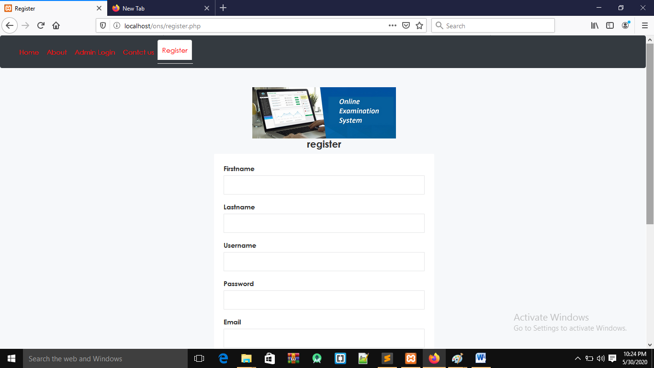

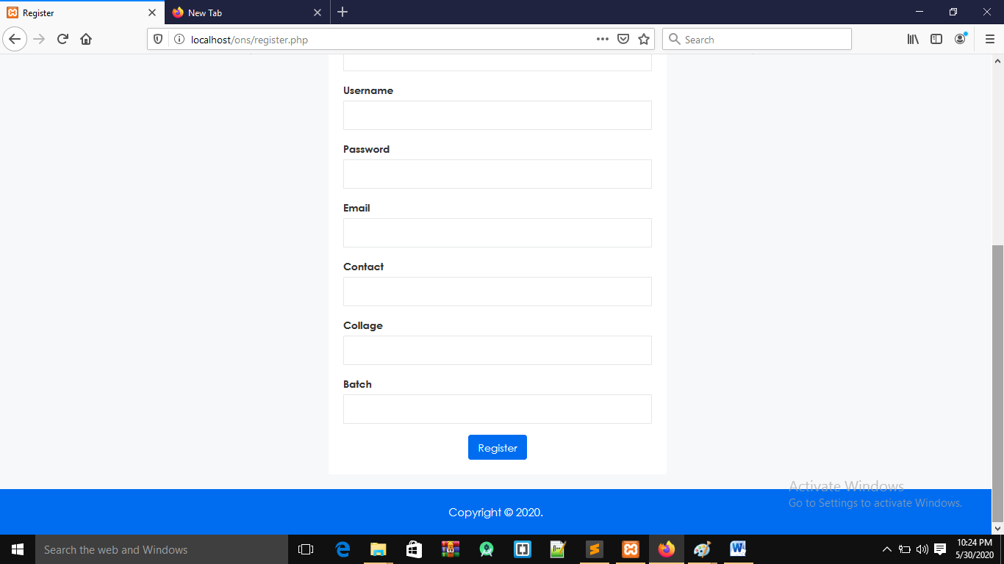

1. **LOGIN WINDOW-**

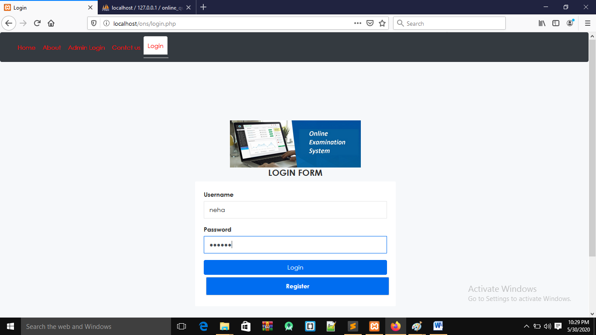

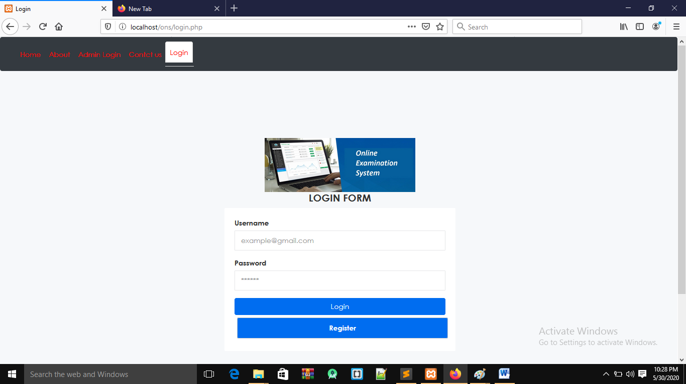

#### 3.Admin login-

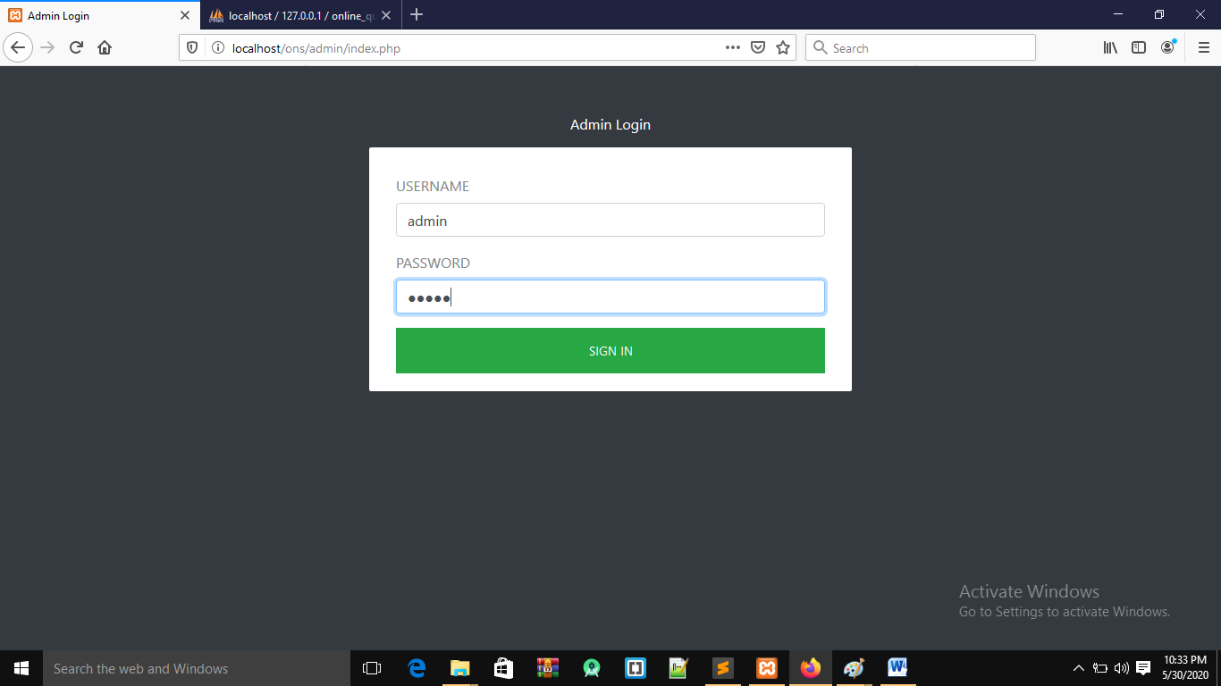

**Admin side:**

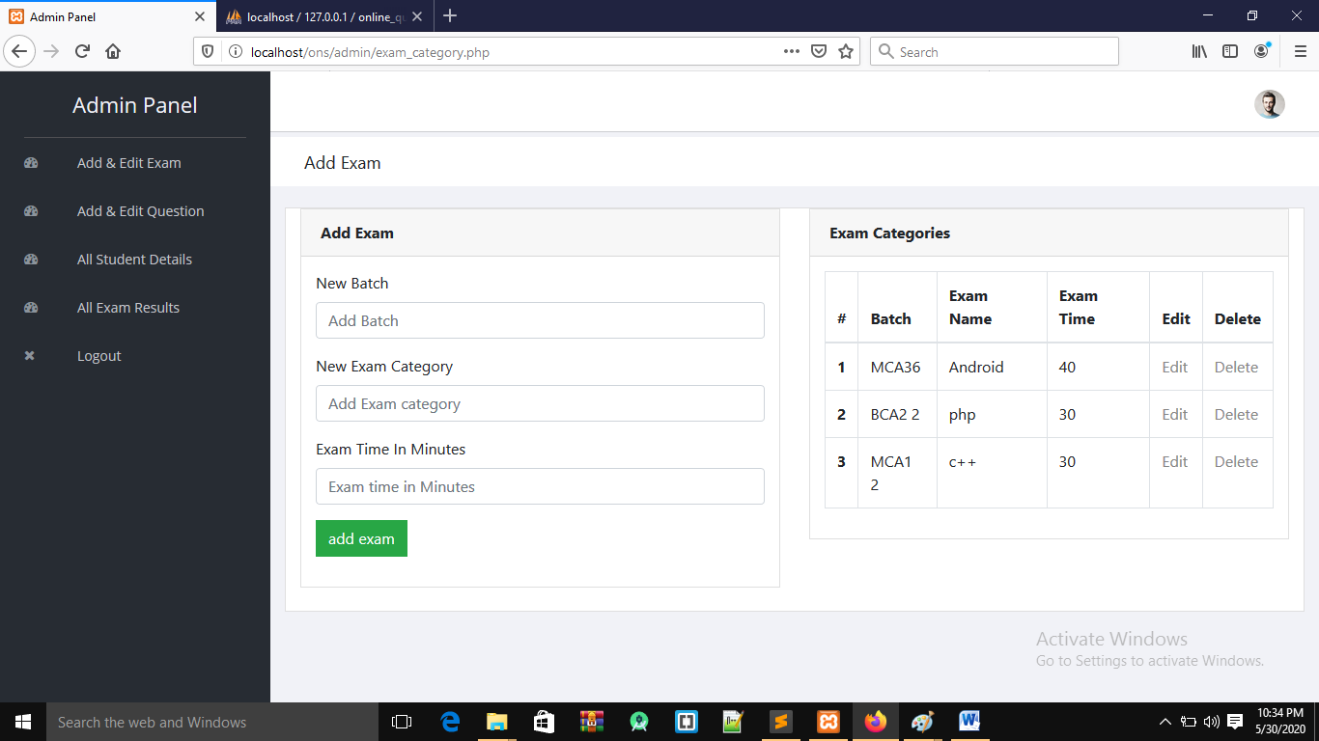

**Add exam window**

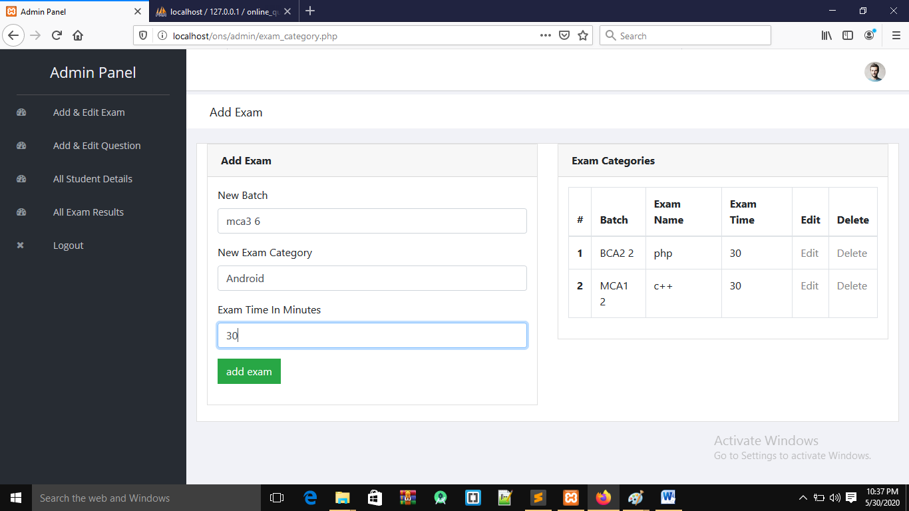

**Add question**

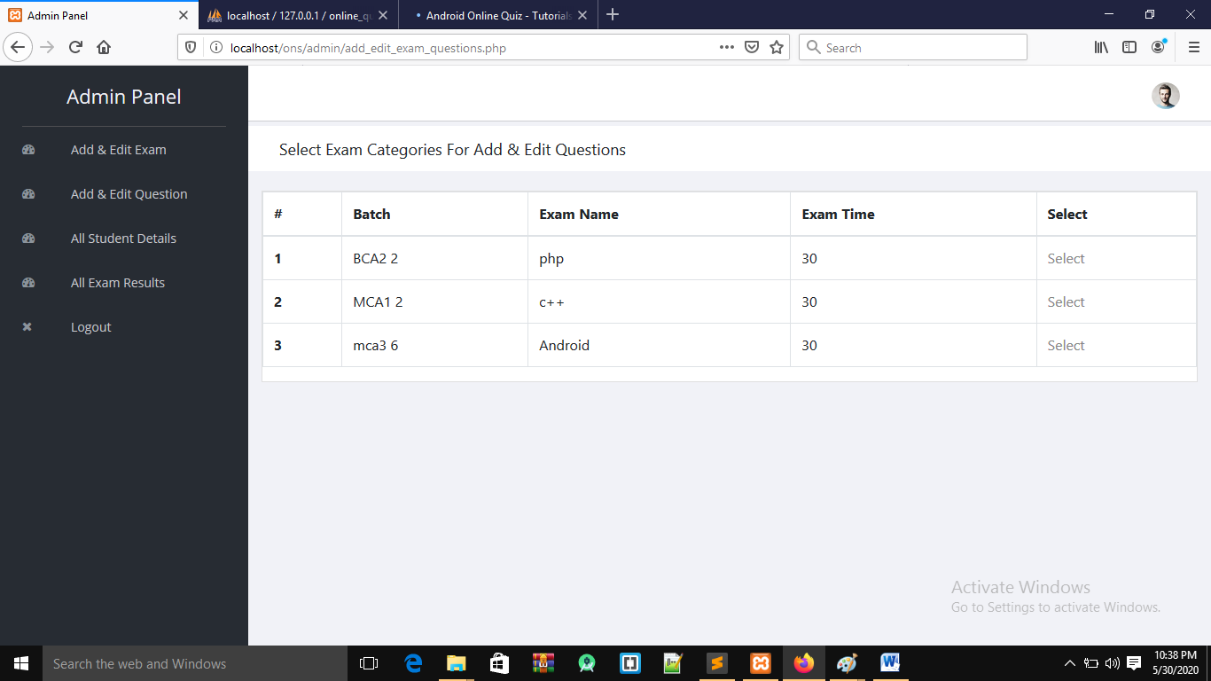

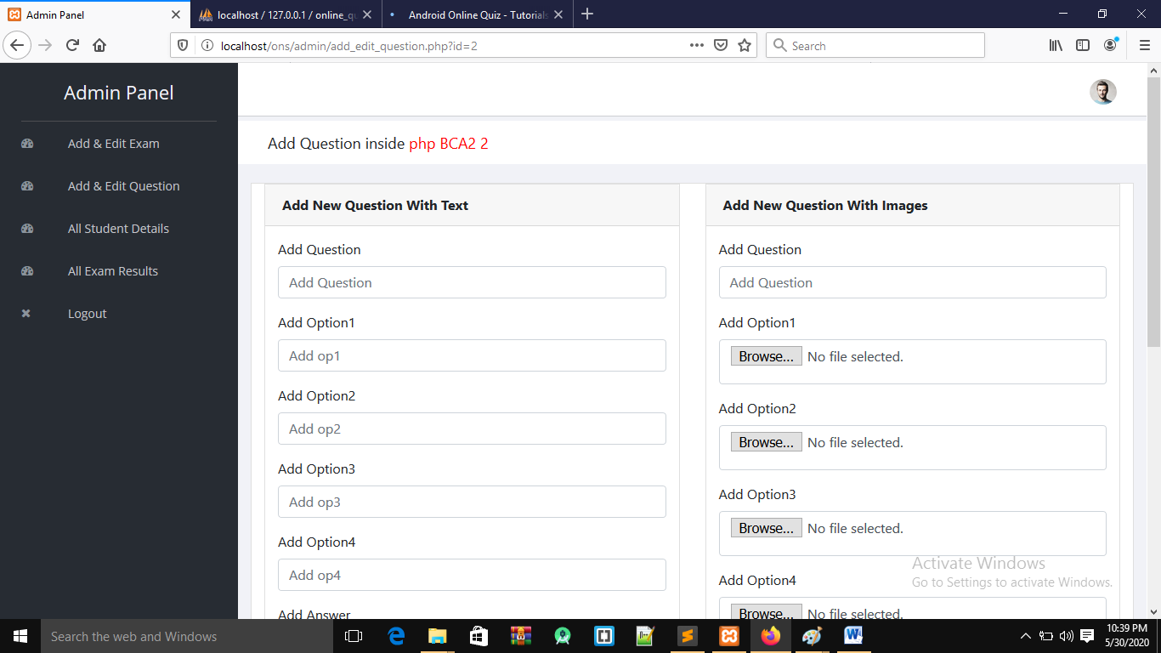

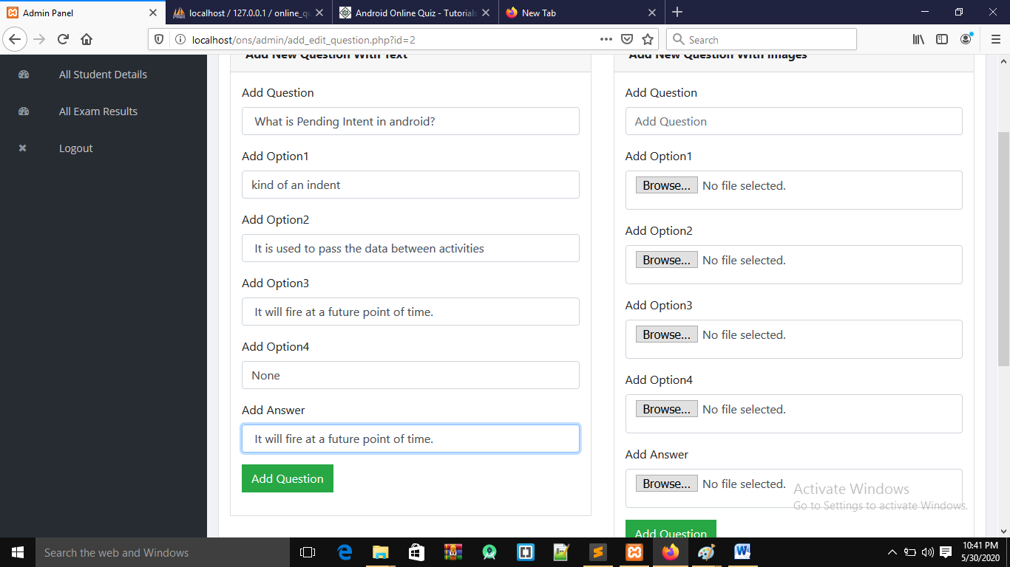

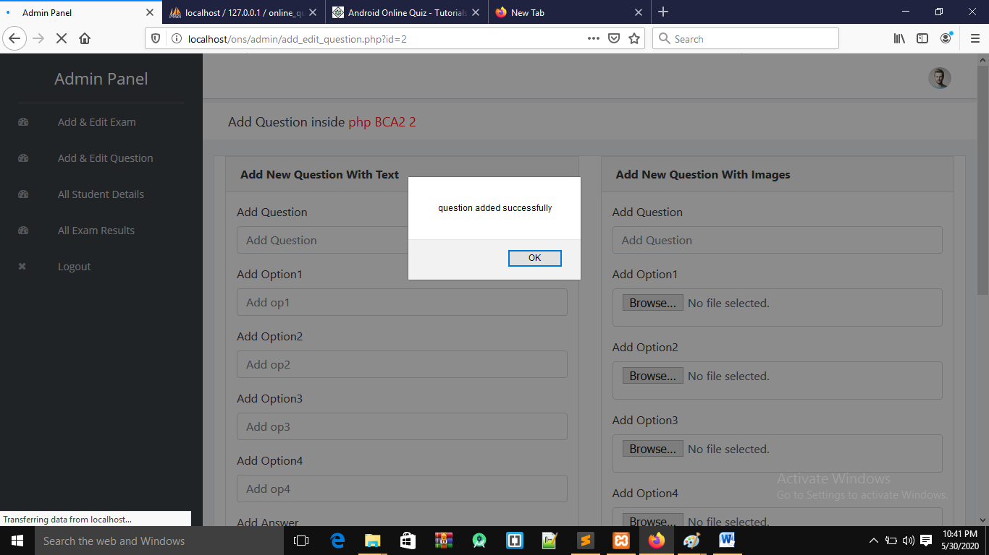

**Student details:**

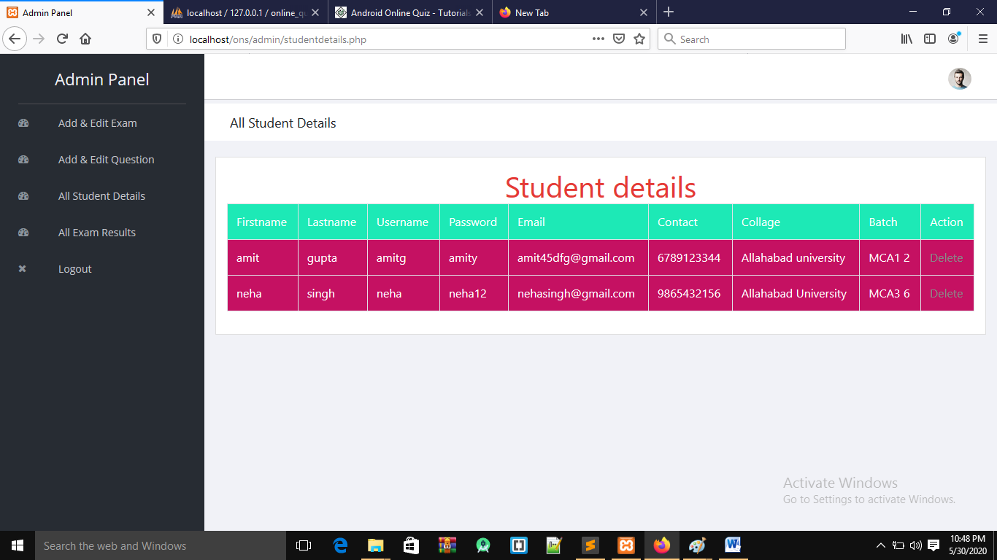

**User side window:**

**Exam form**

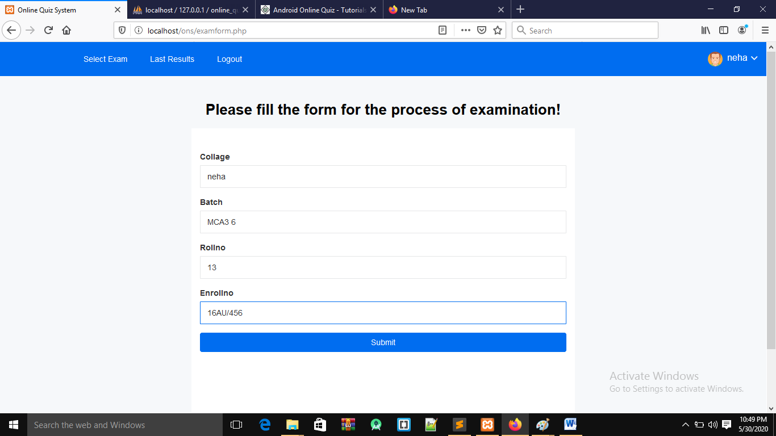

**Select exam**

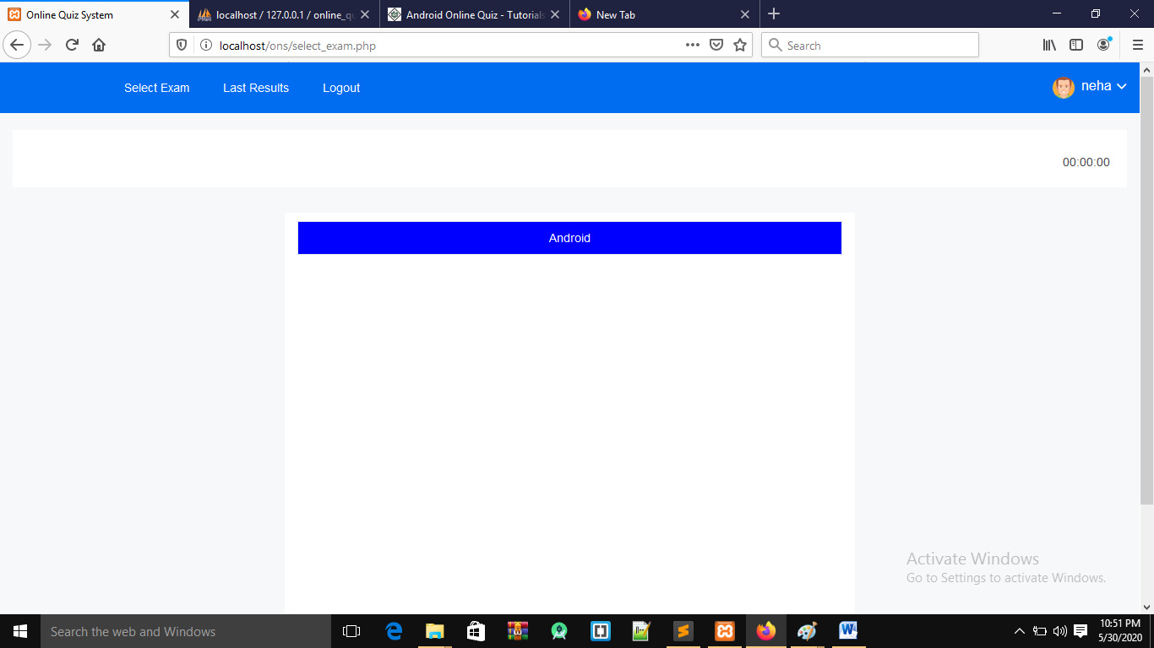

**Exam window**

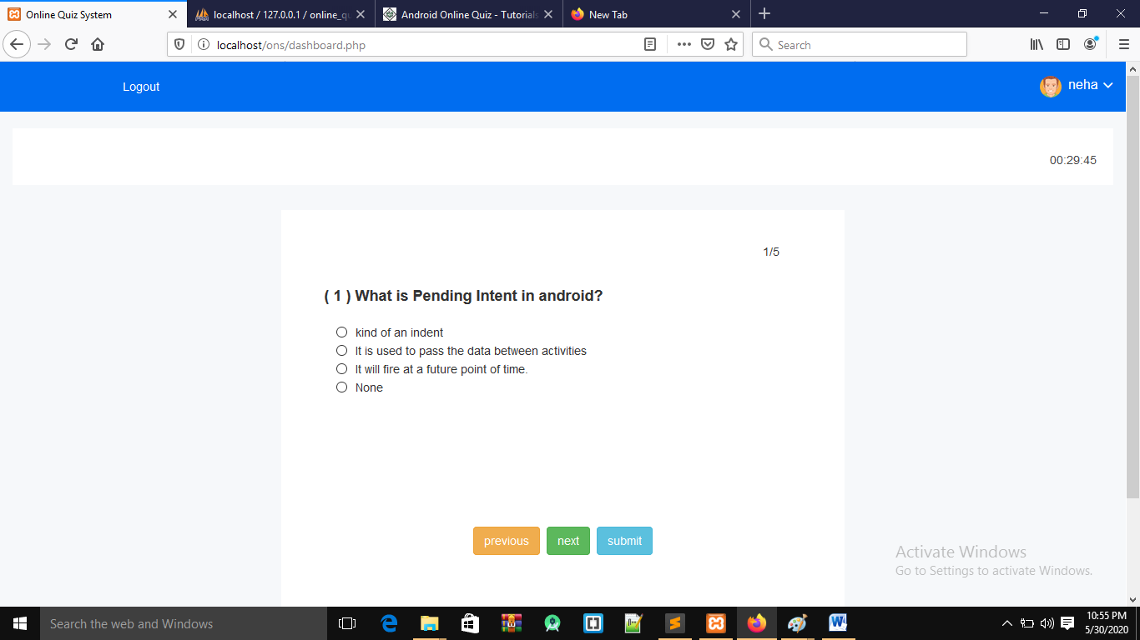

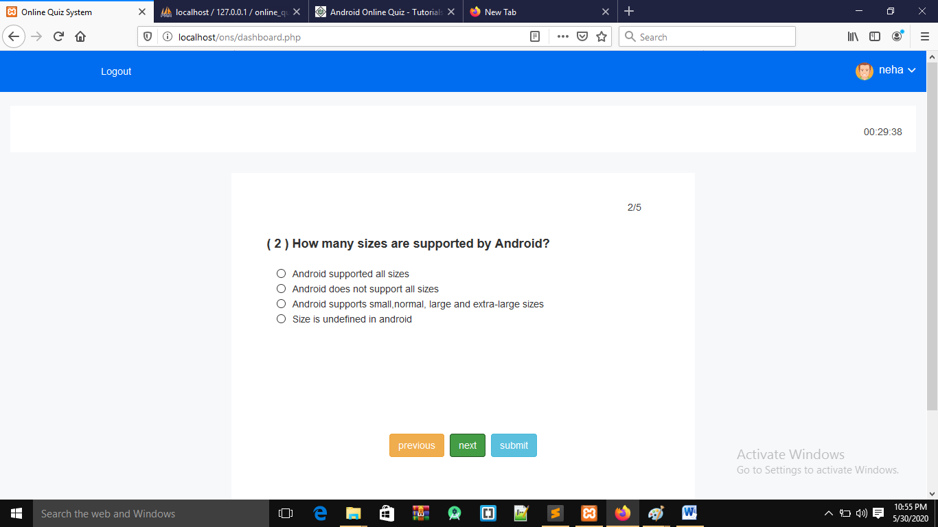

**Resultwindow**

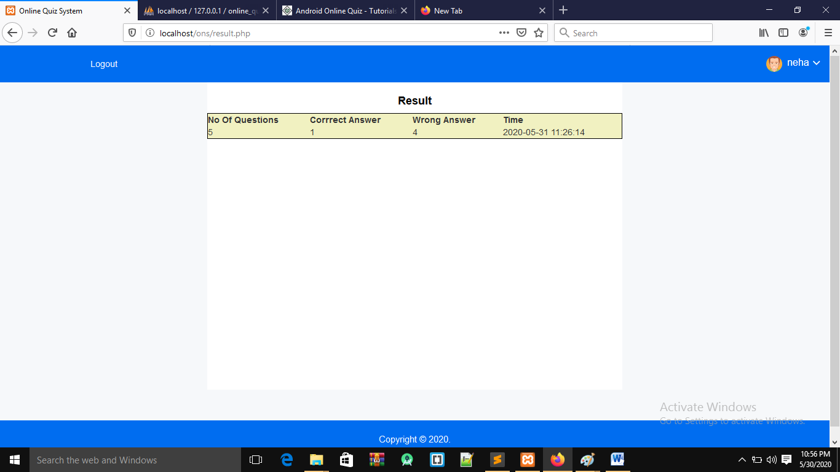

**Old result of user**

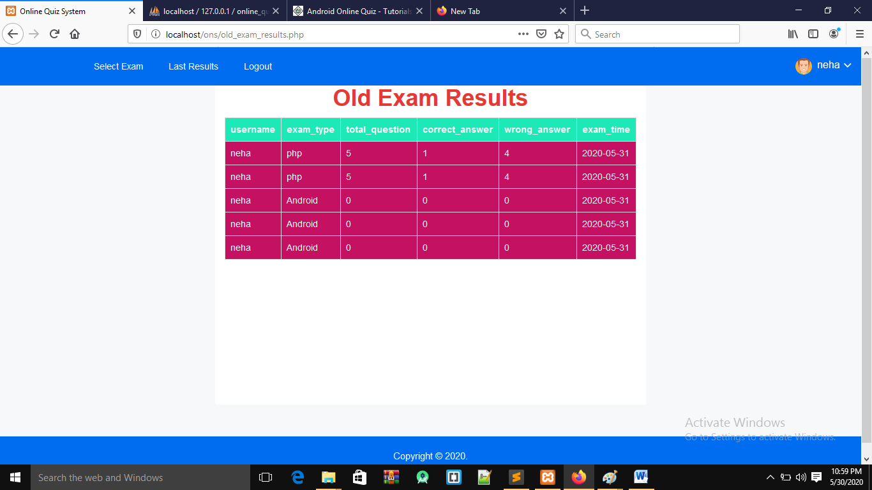

**ABOUT window**

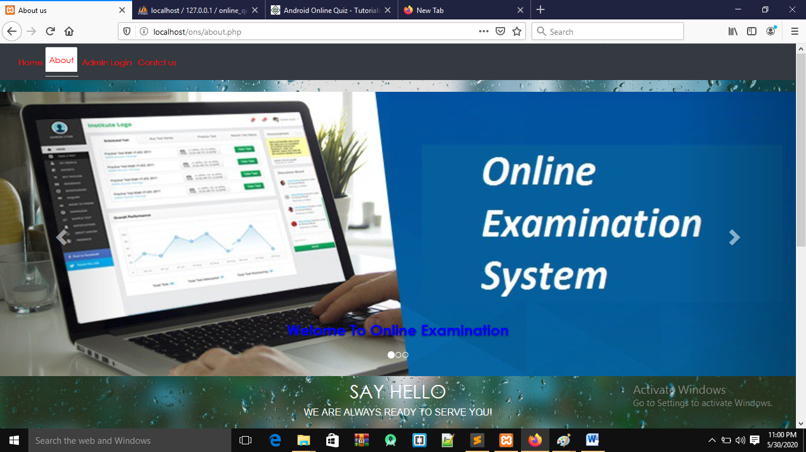

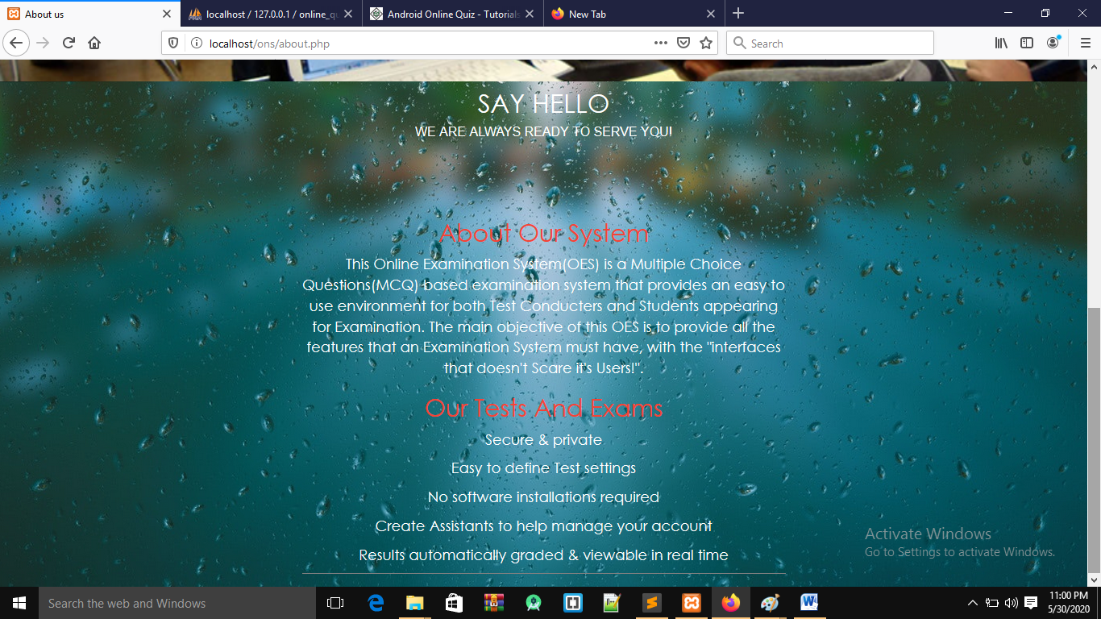

**Contact window**

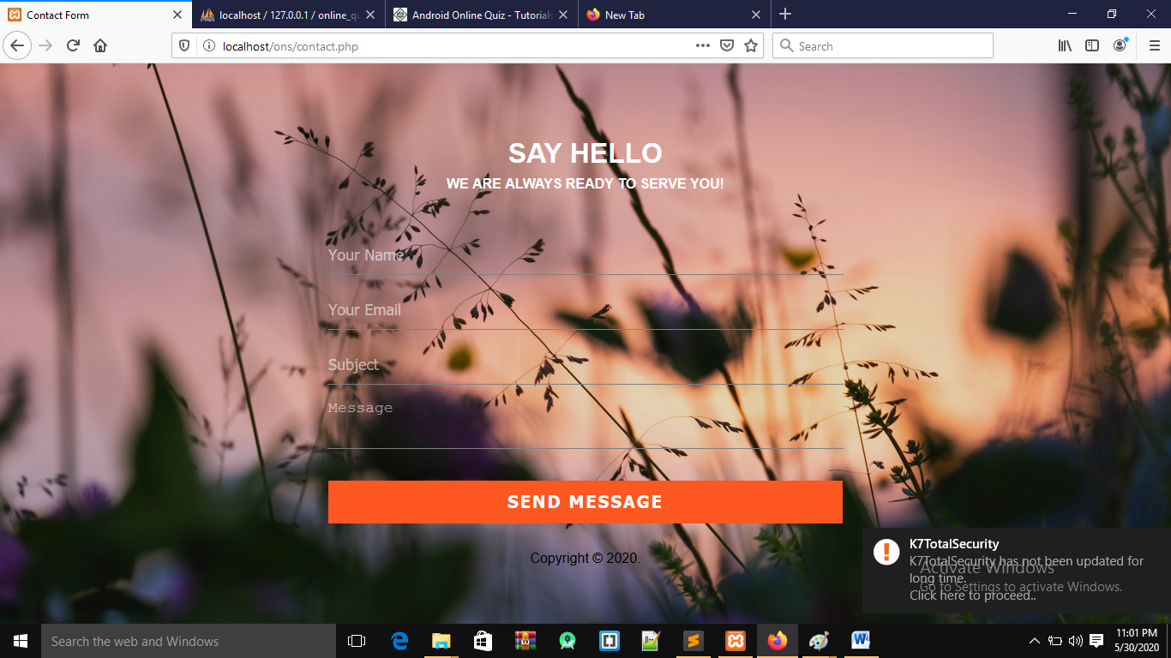

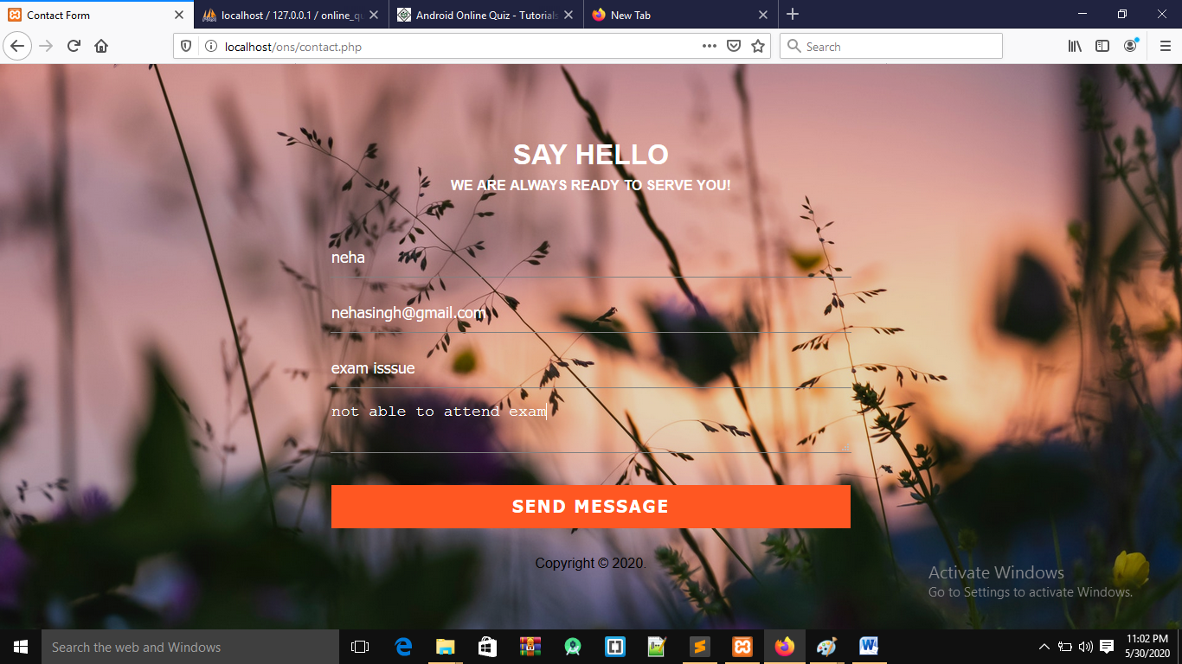

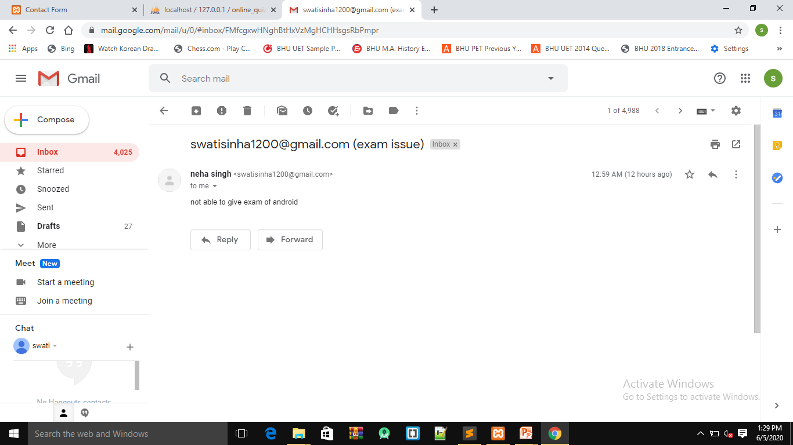

**CONCLUSION**

The package was designed in such a way that future modifications can be done easily. The following conclusions can be deduced from the development of the project.

* + Automation of the entire system improves the efficiency
  + It provides a friendly graphical user interface which proves to be better when compared to the existing system.
  + It gives appropriate access to the authorized users depending on their permissions.
  + It effectively overcomes the delay in communications.
  + Updating of information becomes so easier.
  + System security, data security and reliability are the striking features.
  + The System has adequate scope for modification in future if it is necessary.

**FUTURE ENHANCEMENTS**

Every Application has its own merits and demerits .The project have covered almost be done since the coding is mainly structured and modular in nature. Changing the existing modules or adding new modules can append improvement.This computerized method is a well-suited application for real time.

Well I have worked hard in order to present an improved website better than the existing one’s regarding the information about the various activities. Still ,we found out that the project can be done in a better way. Primarily, when we request information about a particular schedules it just shows the exam and result. And user can access online examination.

So ccaording to my perspective the folowling module can be subjected to further enhancements:

* Add multiple selecting option.
* Add score of result and display ranking of student.
* Add search particular student details in the site.
* Devloped discussion forum
* Multimedia feature support
* Impementation in cloud server
* Record video and analyze
* Faculty can generate lecture on this site and missed class can view those video
* Add more browser security feature
* Preview of question paper with its answer
* Gerate the report based of its results.

#### REFRENCES

The following books were referred during the analysis and execution phase of the project

* **Books Referred:**
* PHP AND MYSQL WEB DEVELOPMENT --- LUKEWELLING,LAURA
* **Websites Referred:**
* <https://www.w3schools.com/php/php_mysql_delete.asp>
* <https://www.w3schools.com/bootstrap/bootstrap_alerts.asp>
* <https://www.youtube.com/results?search_query=how+to+turn+off+less+secure+apps+in+gmail+>
* <https://github.com/PHPMailer/PHPMailer>
* <https://github.com/durgesh-sahani/send-email-using-smtp-phpmailer-localhost>
* <https://www.w3schools.com/php/func_array_next.asp>
* <https://www.w3schools.com/php/func_array_pos.asp>
* <https://www.w3schools.com/php/>
* <https://www.w3schools.com/xml/ajax_intro.asp>
* <https://getbootstrap.com/docs/4.0/getting-started/introduction/>
* <https://www.w3schools.com/css/css3_animations.asp>
* <https://www.webslesson.info/2019/11/php-mysql-based-online-exam-system-project.html>